Downham Market Jubilee Community Centre Booking Form
Bookings are not confirmed until we have received all forms returned / completed and payment of the deposit.
About You

Organisation/Business/Hirers
Name:
Your Address:

Invoicing Address:
(if different from above)
Email address:
Telephone Number:
Mobile:

About your event

Event Name: Please provide details of event: Type, if alcohol will be on premises, ticket selling etc. |  |  |  | Security booked if appropriate  (Please contact us for details of our preferred security companies)
Bar
If you wish to have a bar with alcohol sales a Temporary Event Notice must be obtained from KLWNBC
Date/s:
Hire Charge  £14 per hour |  | Start time: End time:  Total Hours (including set-up and set-down) x £14 p/hour
Maximum capacity |  | The number of people in the building must not exceed 100
Your room/equipment requirements

Theatre | 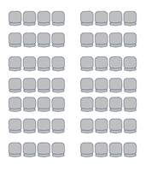 |  | Meeting
Boardroom |  |  | Classroom |  | 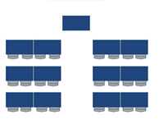
Other Layout
Please specify
Chairs required number

Other requests:

Should you require a Disco, Lighting, Sound, or Microphone, this can be arranged through J R Light & Sound. A price list can be found on the Downham Market Town Council website.

Deposit payable to secure booking

Total Hire Charge | Amount Payable on Booking | Amount Payable 4 weeks Prior to Hire
Total Charge £100 or less | £25 | Balance of Full amount
Total Charge £101 - £199 | £50 | Balance of Full amount
Total Charge £200 upwards | £100 | Balance of Full amount
In addition
A returnable deposit of £150.00 may be required to cover damage and breakages if security is not booked.

For more information contact DMTC on: Tel: 01366 387770 or email info@downhammarkettc.co.uk
I certify that I have read, understood and agree to the ‘Terms and Conditions of Hire’, ‘Fire and Emergency Procedures ‘, and ‘Privacy Notice’. I understand and agree hire costs must be paid 28 days prior to the event. I agree to clear up and remove my refuse from the venue prior to my departure. I am 18 years or over.
Signature
Print Name
Date

