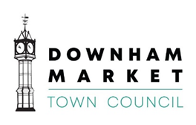

15 Paradise Road, Downham Market, Norfolk PE38 9HS
Tel: (01366) 387770 E-Mail: info@downhammarkettc.co.uk
Town Clerk: Graham Spark

You are summoned to attend a meeting of the Human Resources Committee to be held on
Friday 4th November 2022 at 3.30pm to discuss the business on the Agenda below.

The meeting will be held at the Town Council Offices, 15 Paradise Road, Downham Market, Norfolk PE38 9HS.

Yours faithfully

Graham Spark
Graham Spark MBE
Town Clerk
24 October 2022
Agenda

1 | To receive Members’ Apologies for Absence
2 | To receive Members’ Declarations of Interest
3 | To approve the minutes of the meeting held on 21st October 2022
4 | ‘That the Press and Public be excluded from this section of the meeting, as per Standing Order 3D due to the confidentiality of the matter being discussed as it relates to employees of the Town Council.’  To receive the recommendation of the Town Clerk interview panel and make a resolution on appointment.
5 | To agree a starting date and remuneration package for the Town Clerk
6 | To agree the date of next meeting

End

