Special Award Nomination 2024:
Downham Market Memorial Gardens

MEMORIAL PLAYING FIELD
Lynn Road
Downham Market
PE38 9QE
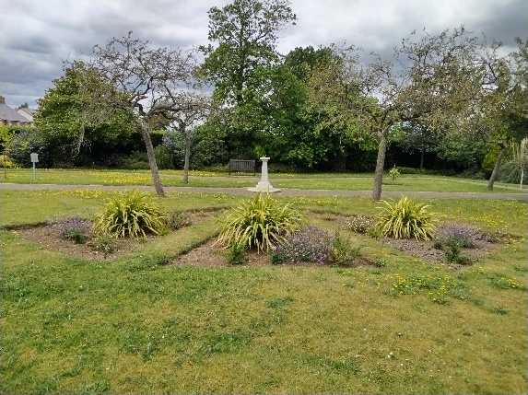
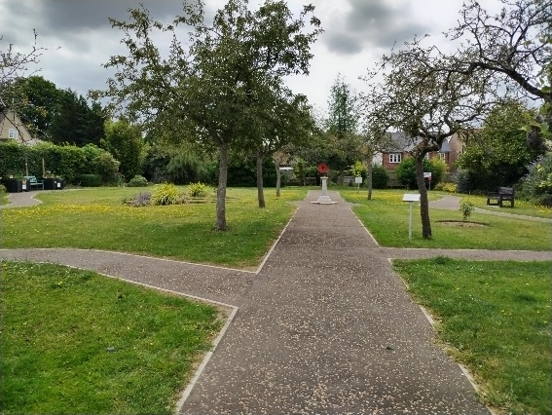
The memorial gardens were created from land gifted to the town in 1949 to honour and remember the fallen of both World Wars.

Over time a discrete and special area – the garden – was created largely by a local school with community and council support.
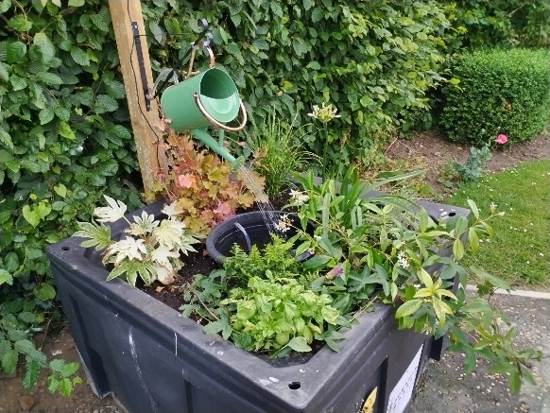
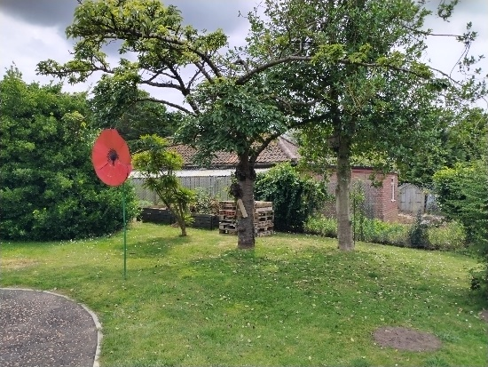

The garden is a serene, accessible space containing diverse planting, sensory areas, and a small war memorial.

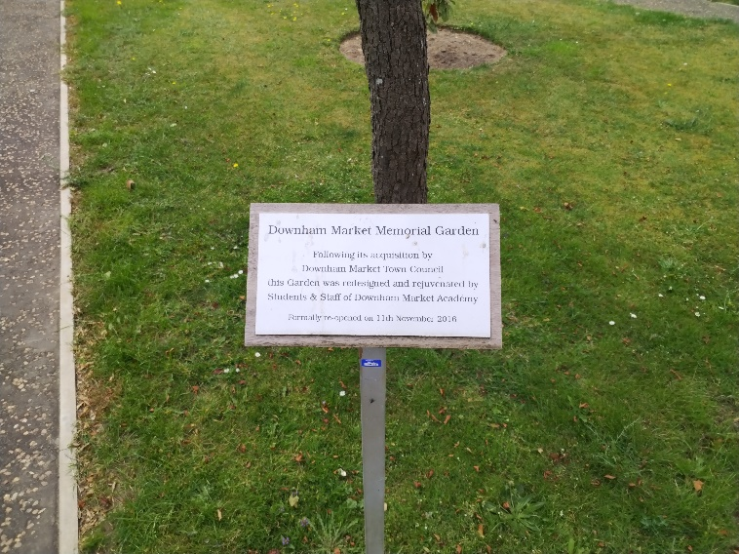
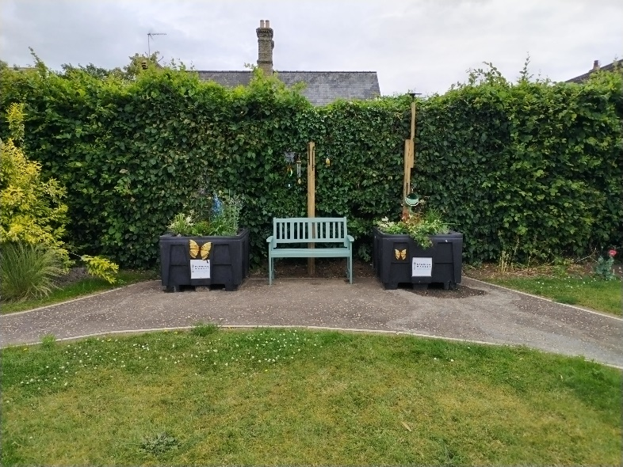
During Remembrance Week community groups such as the Royal British Legion line the wide, accessible pathway with artificial poppies.

