DOWNHAM MARKET:
A TOWN IN BLOOM 2024
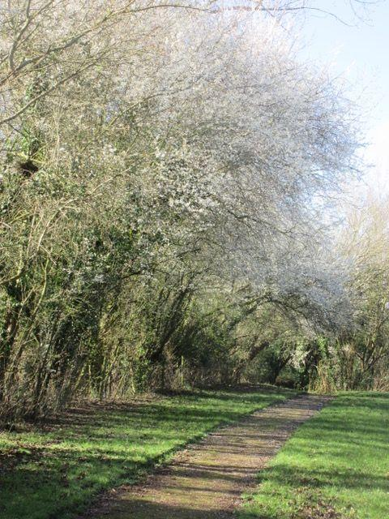

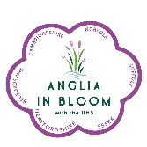
CONTENTS
Introduction Page 2
Judging Route Page 3
Section One- Horticulture Page 4
- Hanging baskets
- Gardens Public and Private
- Public space
- Business and commercial places
- Seed trays
- Allotments and community spaces
Section Two- Environment and Biodiversity Page 10
- Recycle Reuse Litter removal
- Food waste revolution
- Biodiverse areas - The Willows
- Changing the planting focus
- More Trees Please
- Biodiversity and education
Section Three- Community Page 18
- Message from the Chairman of Community Development
- Businesses and charities - the heartbeat of the town
- The town in bloom
- Annual Highlights
- Downham a town of diverse cultures
Future Plans Page 28
- Planting the future
Conclusion and Thanks Page 29

INTRODUCTION
Welcome to the In Bloom Committee for 2024! As we embark on another year dedicated to enhancing the beauty and vitality of our community, we are excited to gather individuals who share a passion for nurturing and celebrating nature's gifts. The In Bloom Committee is not just about planting flowers; it's about fostering a sense of pride, environmental stewardship, and community engagement.
In Bloom is more than a mere aesthetic endeavor; it's a movement towards creating vibrant, sustainable environments that uplift spirits and connect people to their surroundings. As we witness the profound impact of green spaces on mental well-being and social cohesion, our commitment to nurturing and preserving these spaces becomes increasingly vital.
This year, alongside our traditional activities and displays our committee has begun to explore new and innovative approaches to gardening, landscaping, and environmental conservation. We are seeking to harness the collective wisdom and creativity of our members and the wider community to cultivate green spaces that inspire, educate, and rejuvenate. Whether a seasoned horticulturist, an aspiring gardener, or simply someone who appreciates the beauty of nature, there's a place for everyone in our community to take part and we hope this year’s new activities reflect this.
Together we hope to sow the seeds of change, nurturing not only plants but also a sense of belonging and connection among our neighbors in the wider community. Join us as we embark on this journey to make our community bloom brighter and more beautiful than ever before.
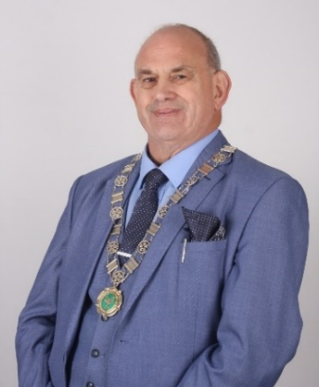

Michael Lane
Deputy Mayor
Chair of Downham in Bloom

JUDGING ROUTE
This year’s route has been designed to highlight the range of horticultural and natural environmental features of the town - we hope you enjoy the following route:

Meet at Paradise Road Council Office- Welcome and outline of the day. Walk across to the Happy to Chat bench
Happy to Chat Bench Friendship Feature- turn right on Paradise Road to the Swan Centre
The Swan Centre- Proceed to Memorial Gardens
Memorial Garden- (including the field and Community Orchard) from Lynn Road, turn left onto Bexwell Road to Downham Market Academy
Papillion Project- turn right onto Bexwell Road, then left into Howdale Road and left into the Jubilee Community Centre
Jubilee Community Centre- through the roadway, then right onto Rouses Lane, and left onto Howdale Road
Howdale- Howdale Road onto Church Road and around Tesco Roundabout
Town Sign, WI bed and Borough Bed- Church Road, then turn left onto Priory Road
Priory Badge Bed- Continue on Priory Road
Discover Downham- left onto Railway Road, then left at Lawn Boy onto Primrose Avenue
The Willows- back to Railway Road, then right into Fairfield Road
Ashville Care Home- Left out of Fairfield Road and onto Railway Road
Train Station- Left onto Railway Road, Bridge Street
Whalebone- Bridge Street, left through the Hollies Car Park
Methodist Church- Back through the Hollies Car Park

Finish at the Town Council Office on Priory Road
SECTION ONE - HORTICULTURE
- Hanging baskets
- Gardens - Public and Private
- Public spaces
- Business and commercial places
- Seed trays
- Community spaces

Hanging Baskets
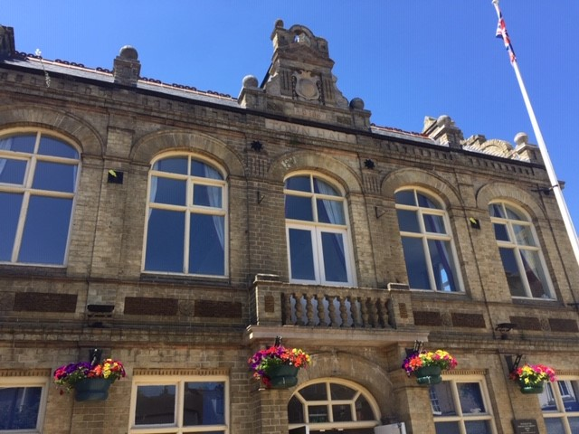
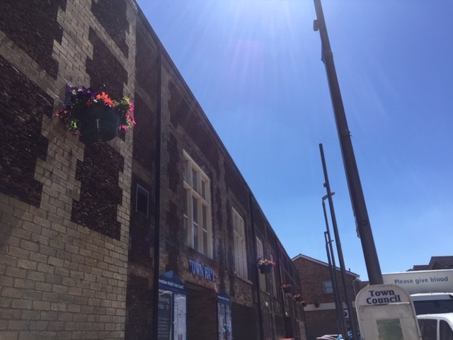
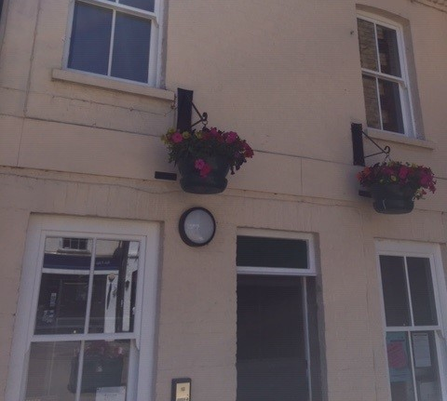
Vibrant hanging baskets mounted on the Town Hall courtesy of King’s Lynn and West Norfolk Borough Council

Baskets situated on the wall of the Town Council’s offices

June 2024

Gardens - Public and Private
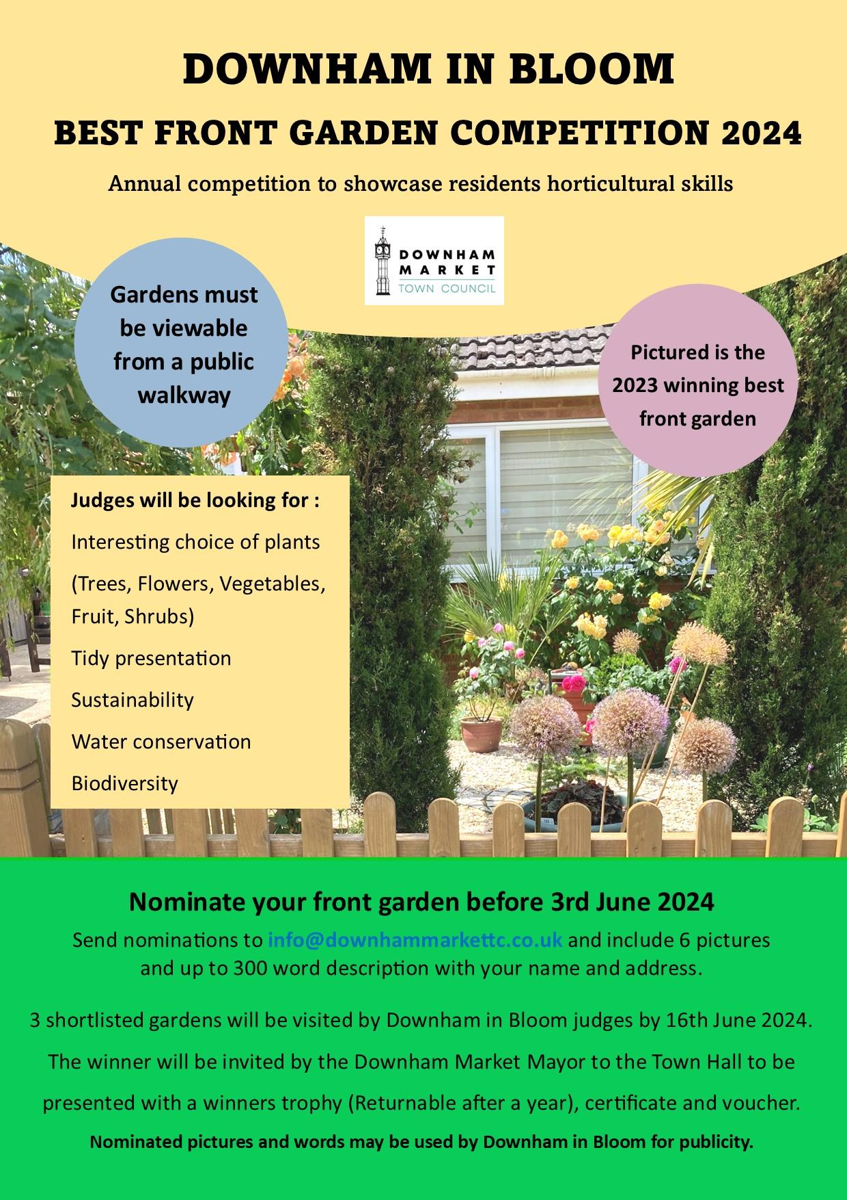
A chance for the community to be involved as Downham in Bloom launches the best front garden competition

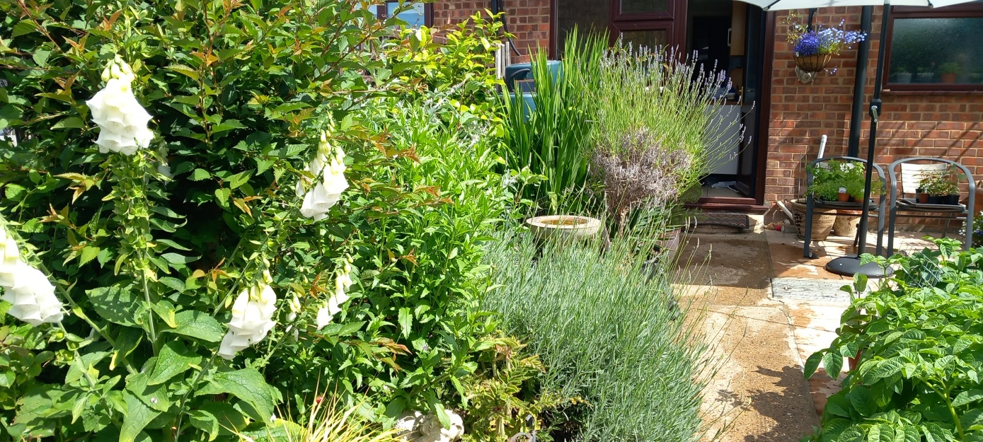
A selection of private gardens (May 2024):
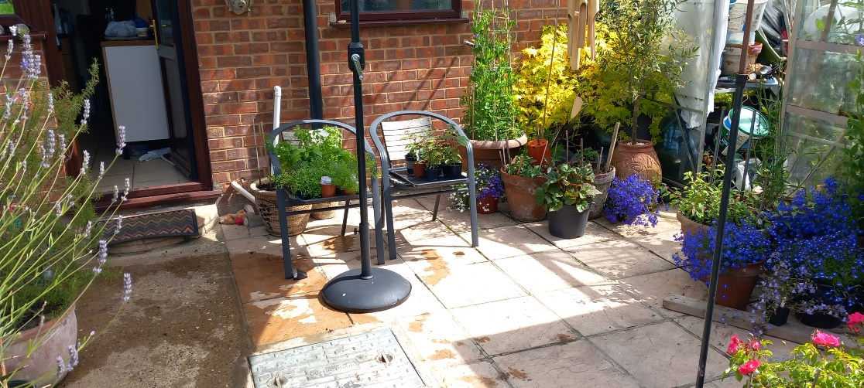
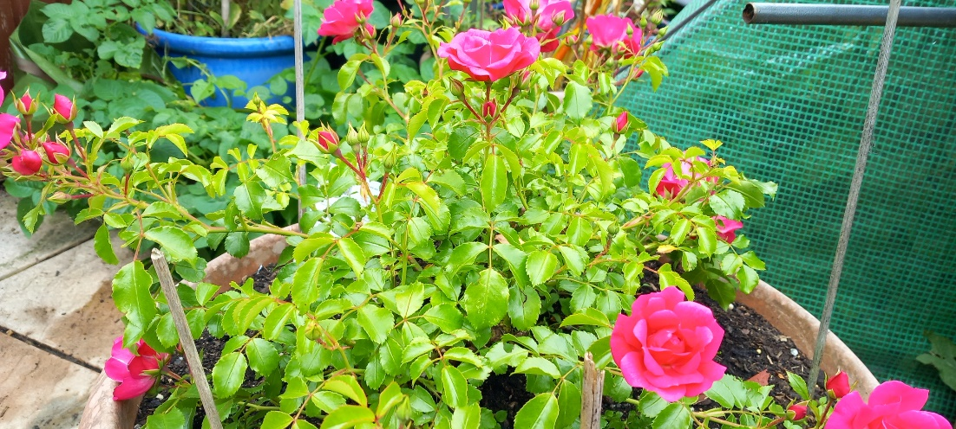

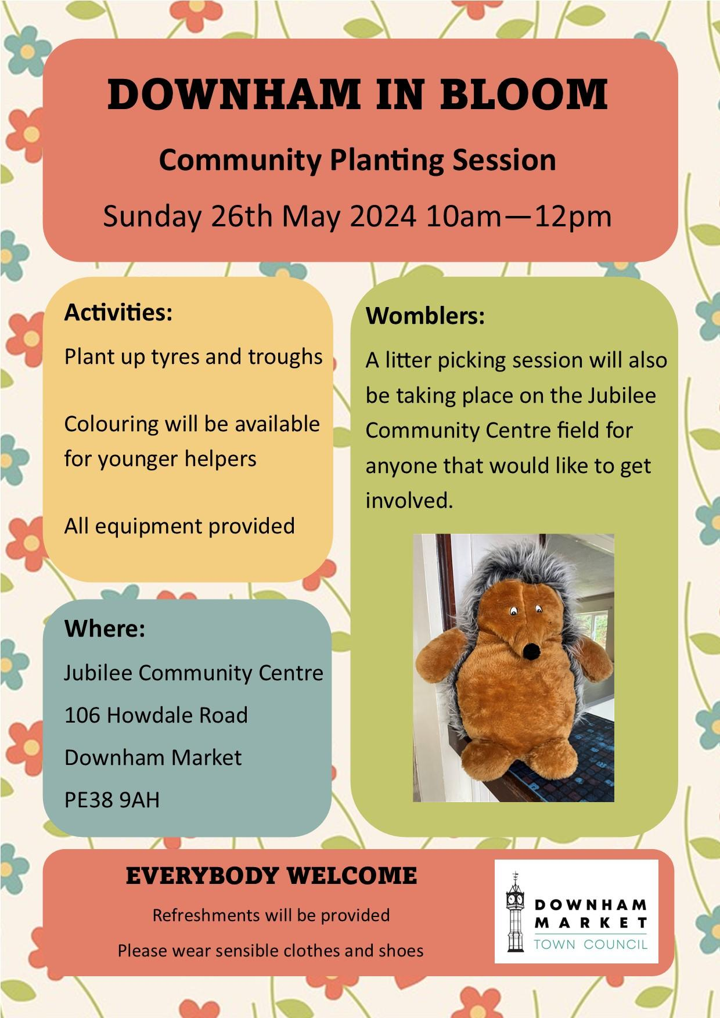

Part of the JCC Regeneration scheme - the first planting on the road to regeneration worked on by local Scouts and Guides and with the community invited to join in

Public spaces
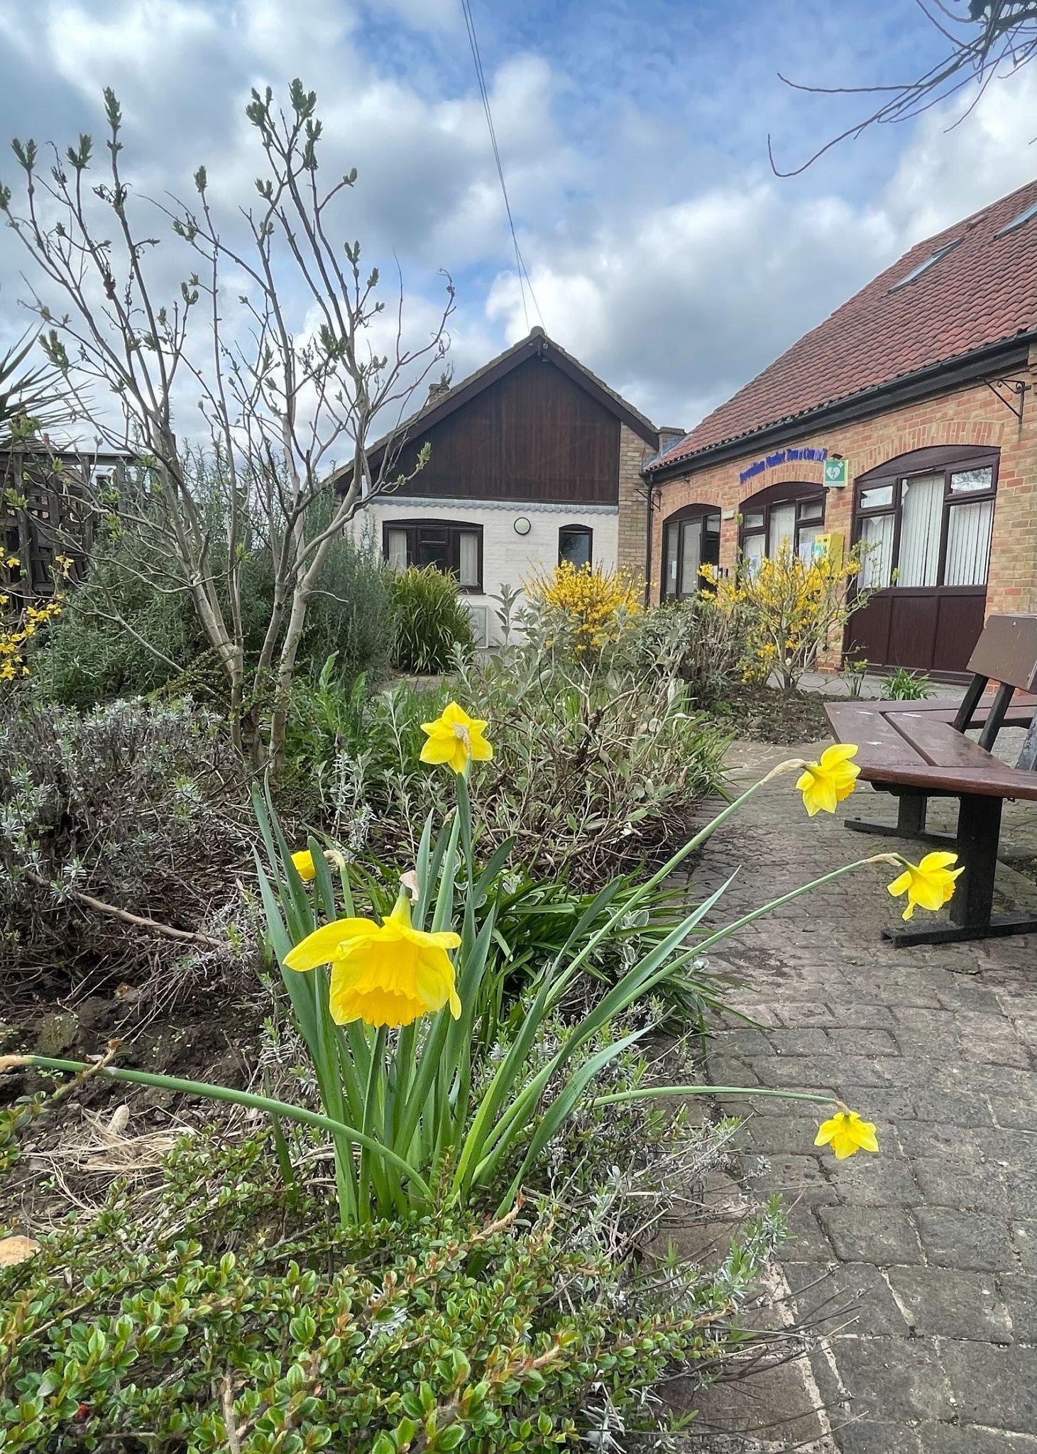

Spring 2024 at the Town Council Offices - year by year the gardens are planted and maintained to ensure all year round displays

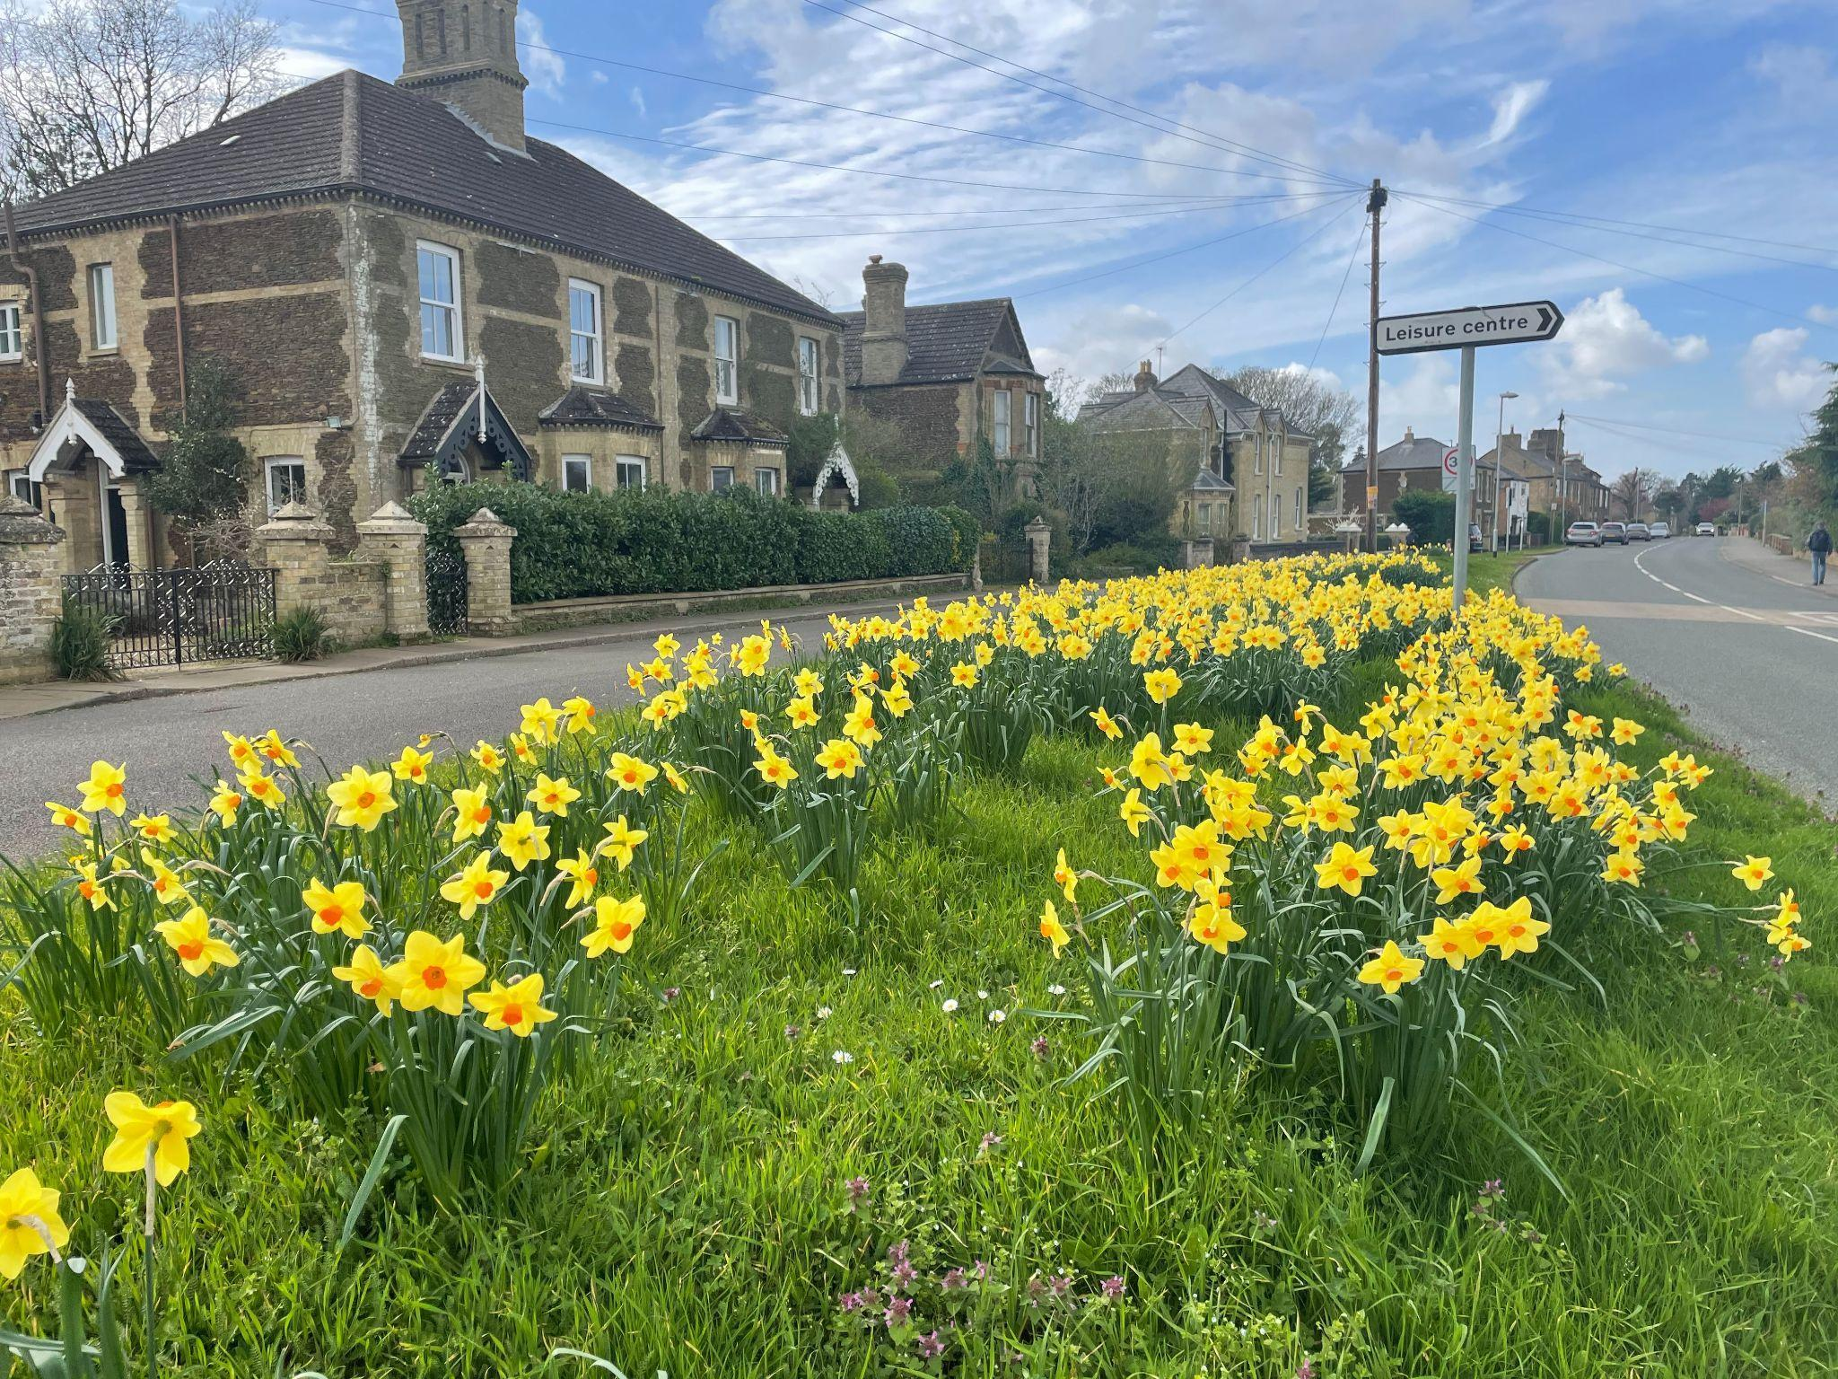
The Bexwell Road area is often overlooked - but where daffodils grow wild in Spring

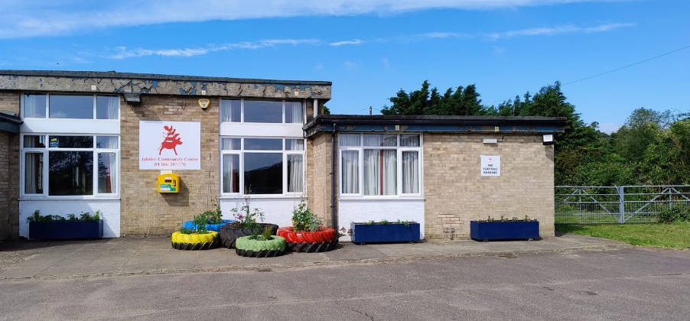
Planted-up containers and tyres recycled into planters containing a selection of vegetables and ornamental plants at the Jubilee Community Centre

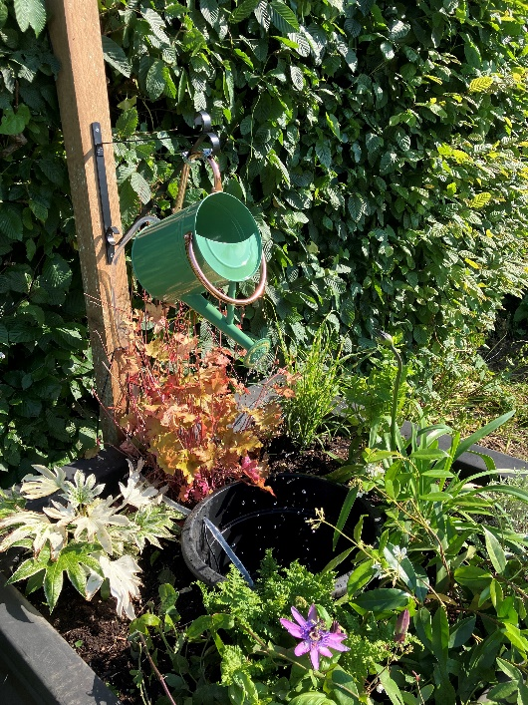
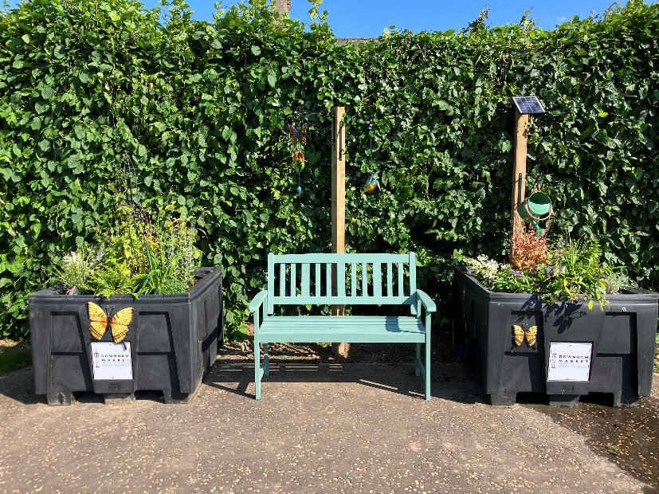
The Sensory Garden started in April 2024 situated in the Memorial Playing Field, including fragrant herbs and plants, the sound of trickling water and grasses rustling in the wind

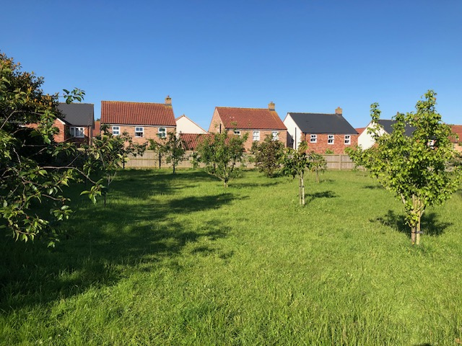
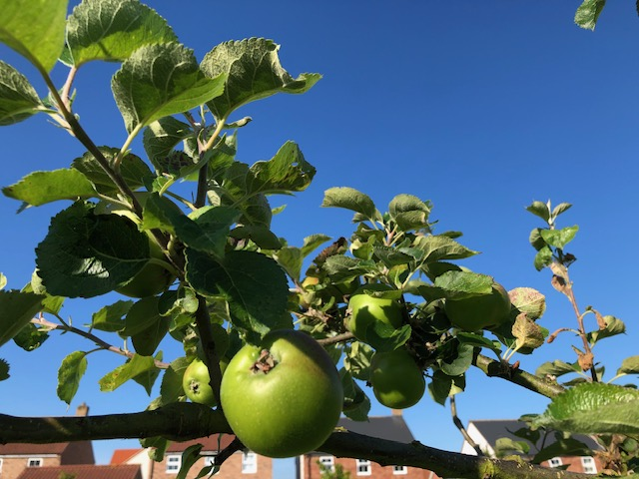
The Sensory Space inside the Memorial Gardens, which are nominated for a Special Award
The Community Orchard featuring varieties of fruit trees such as apples, pears and cherries

An apple ready for picking from one of the community trees (June 2024)
SECTION TWO - ENVIRONMENT & BIODIVERSITY
- More Trees Please
- Recycle Reuse Remove
- Food waste revolution
- Biodiverse areas - The Willows
- Changing the planting focus
- Community education

More Trees Please
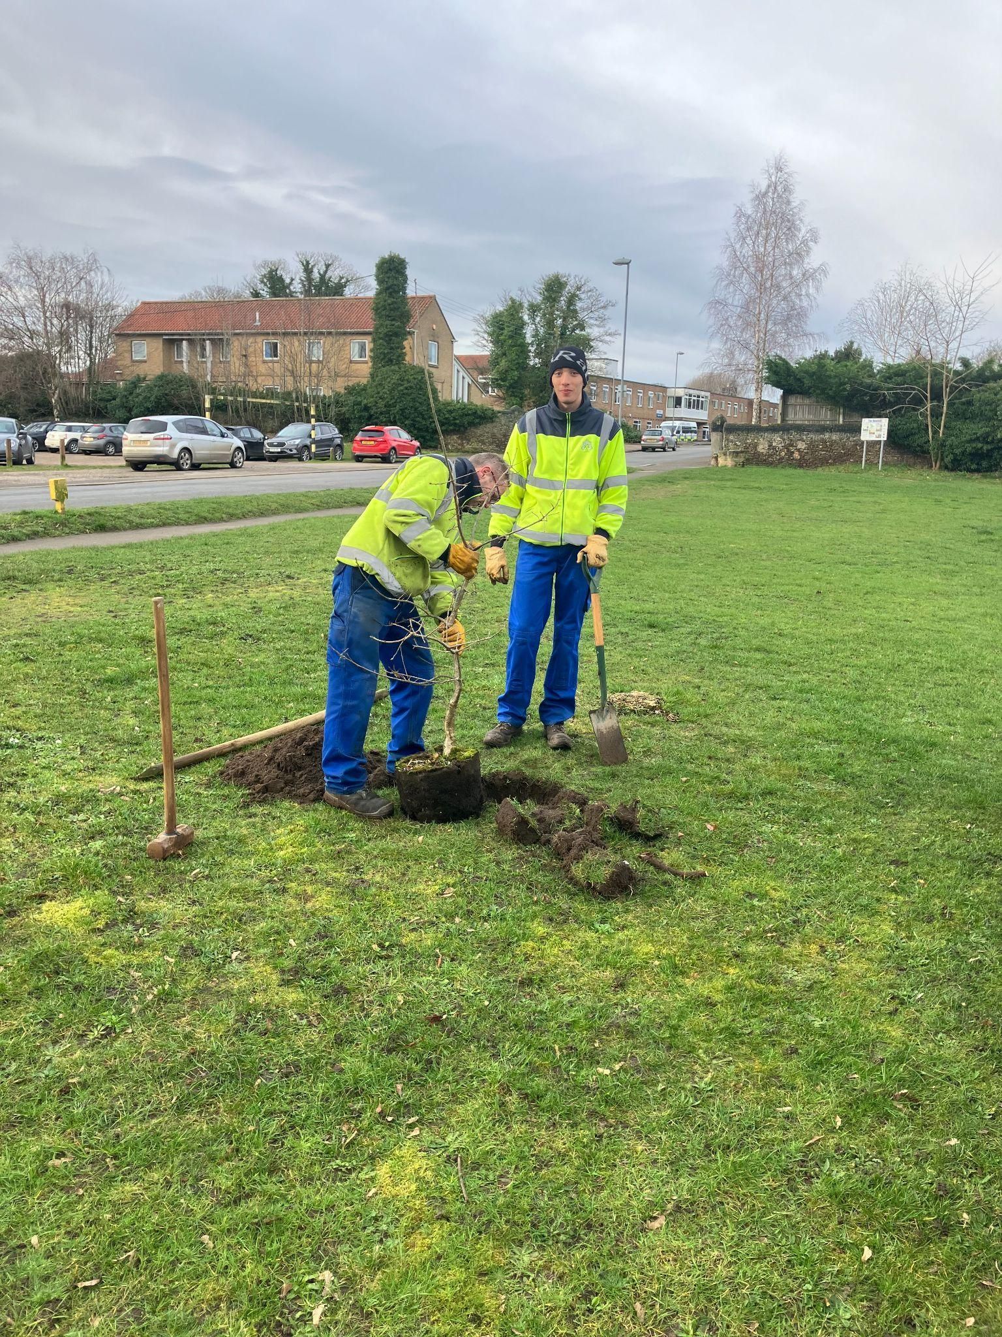
With the support of the Borough Council new trees were planted on the Howdale in the Spring to provide shade and increase biodiversity within the town (February 2024)

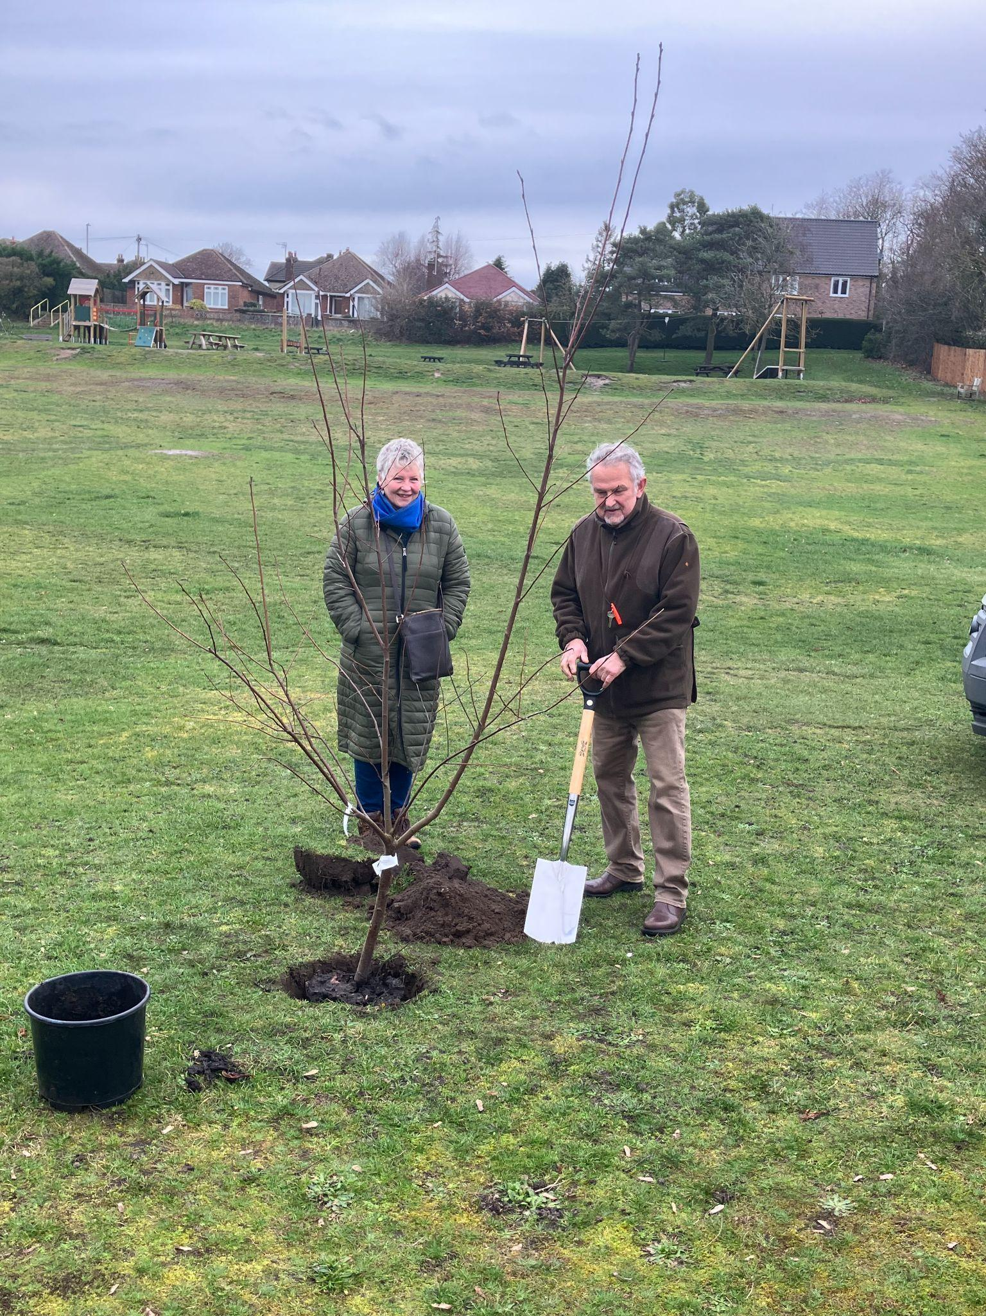
Borough Councillor and Deputy Mayor of King’s Lynn & West Norfolk Andy Bullen joining in the planting of trees donated by the WI at the Howdale playing field

Recycle Reuse Remove
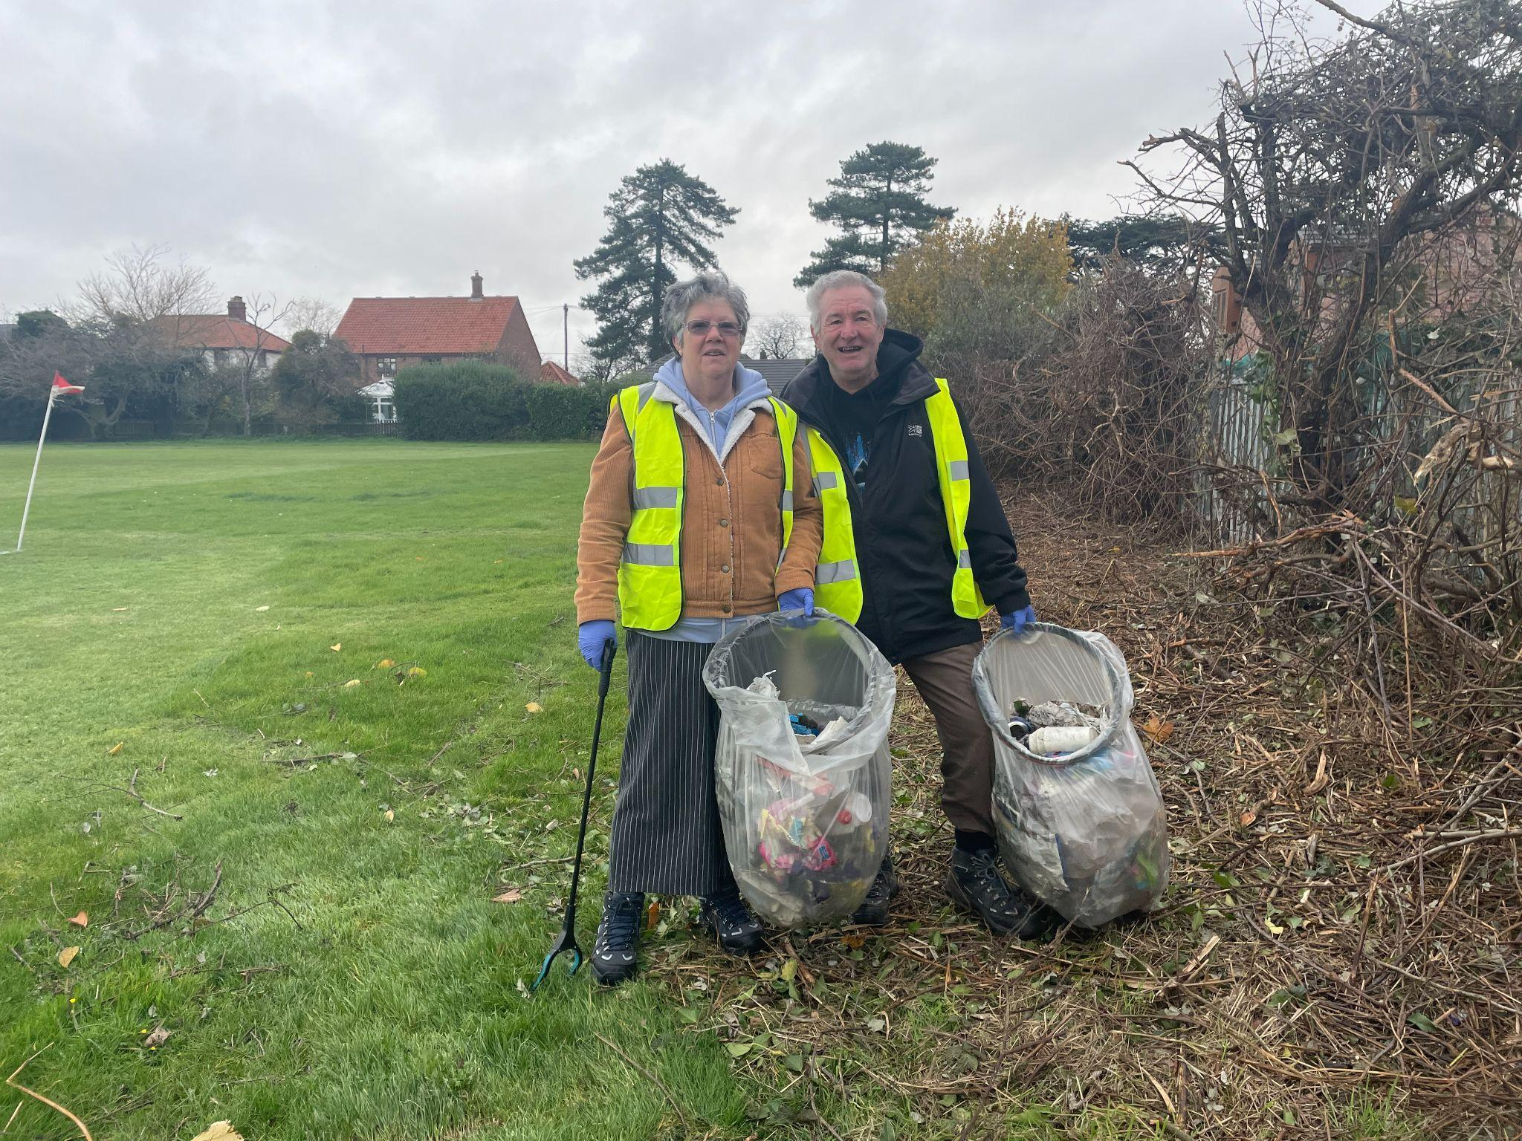

The wombling crew and members of Downham Market Football Club at work in and around the open public spaces of Downham Market in Autumn 2023 and Spring 2024

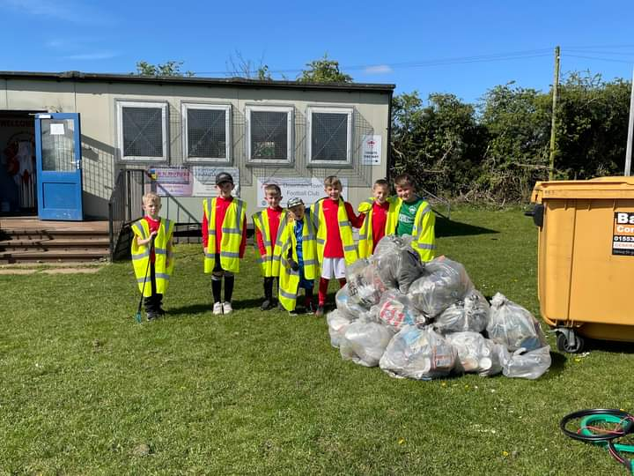
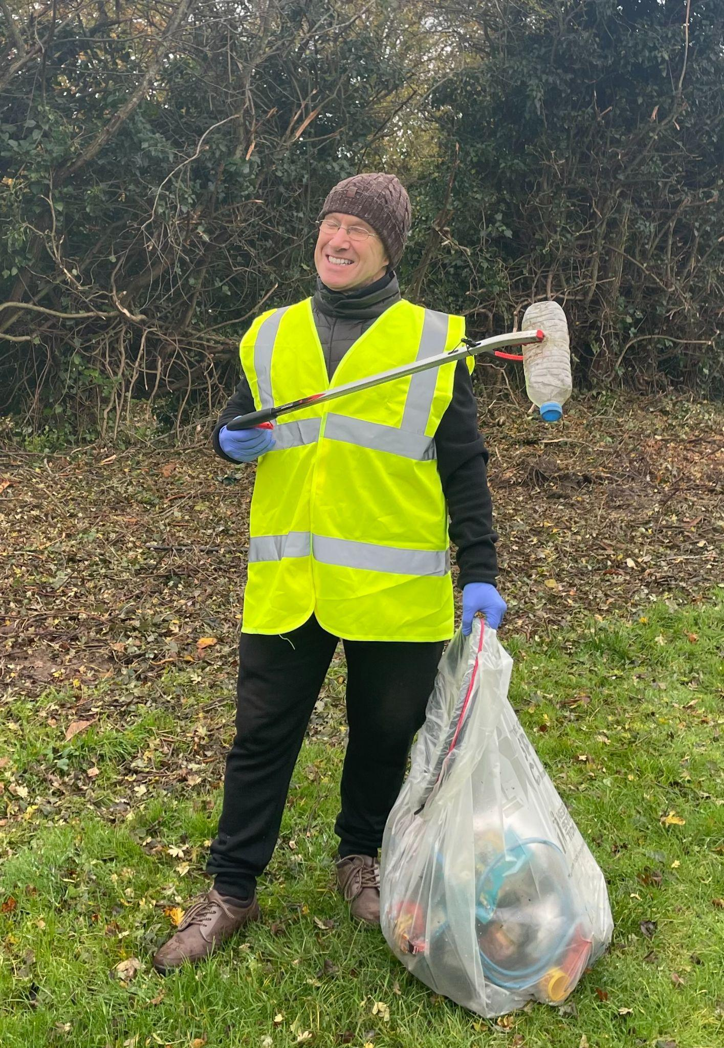

Biodiverse areas: The Willows Nature Reserve

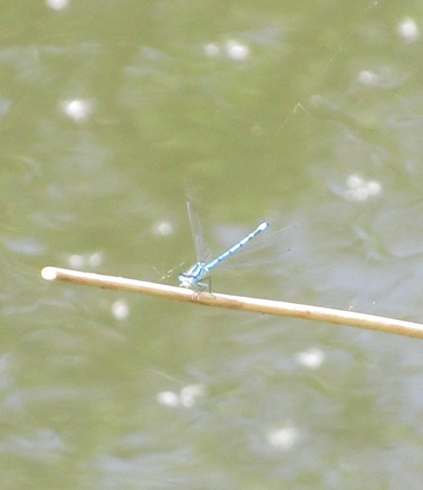
Common Blue Damselfly - part of the diverse ecosystem in the Willows

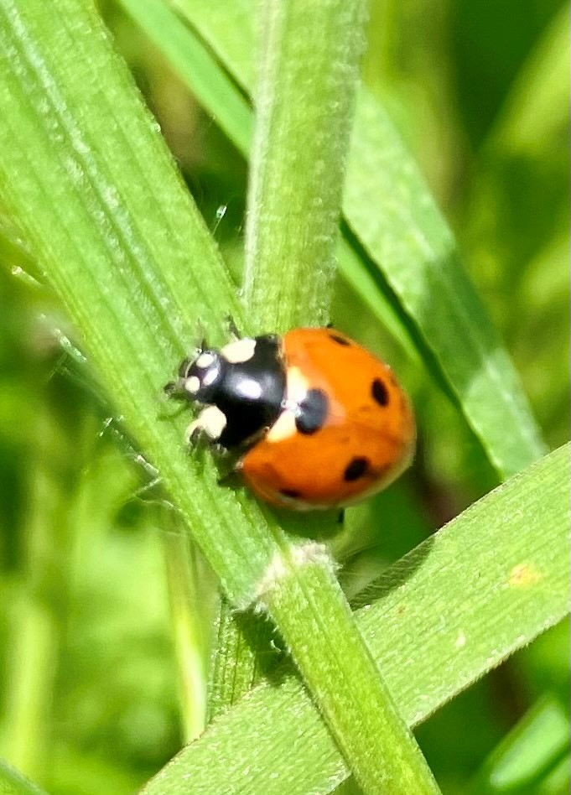

Common ladybird- another example of the wildlife present within our community
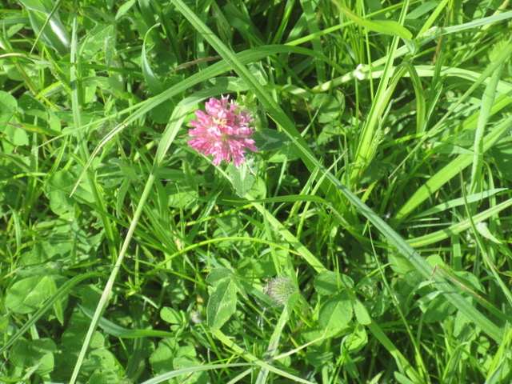
Red Clover grows profusely in the area

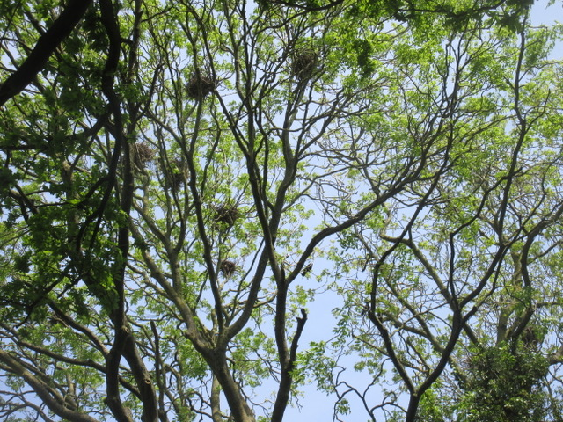
The thriving rookery at the Willows

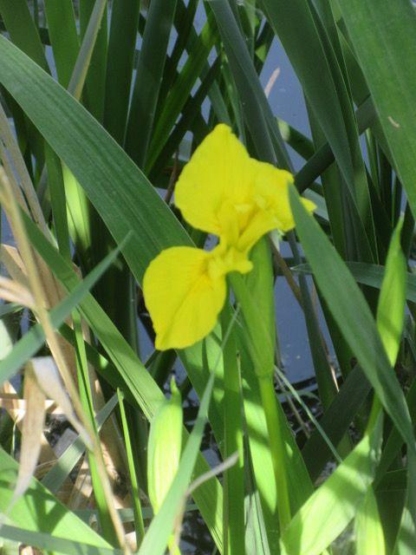
Yellow Flag Irises provide a fine display of flowers in May

Community Education

The Papillion Project - a charity that helps young people create allotments which produce food for their families as well as providing therapeutic support for young people (early Spring 2024)
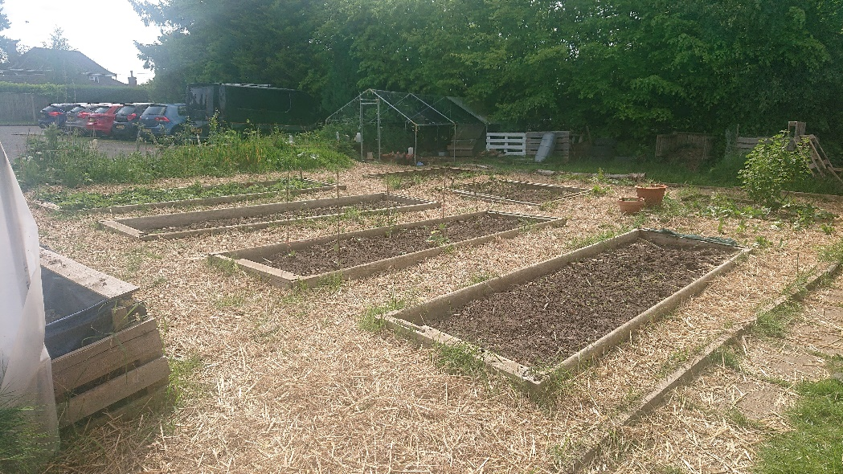

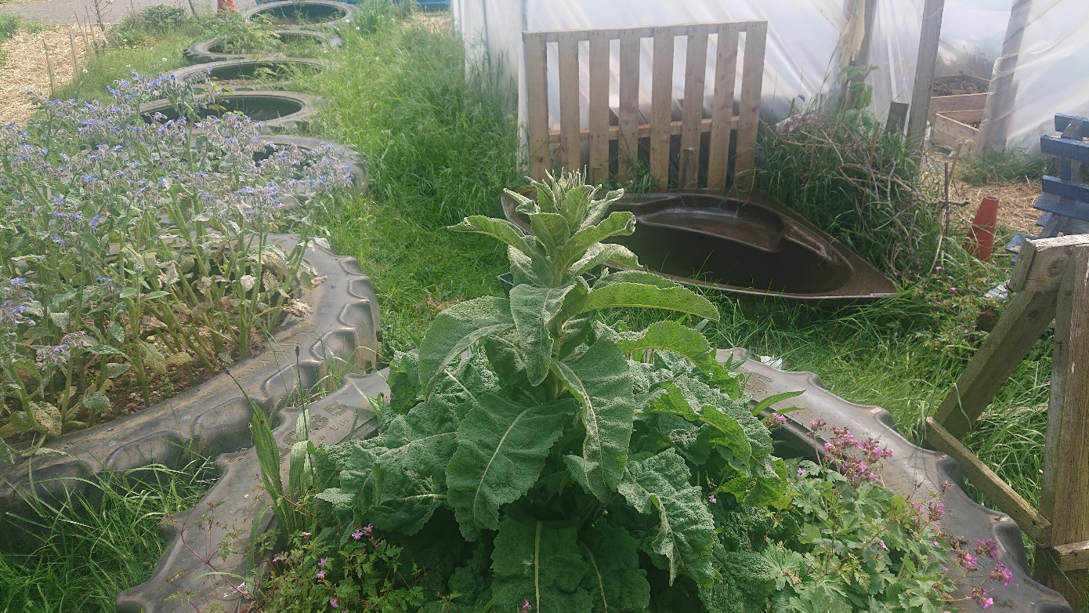
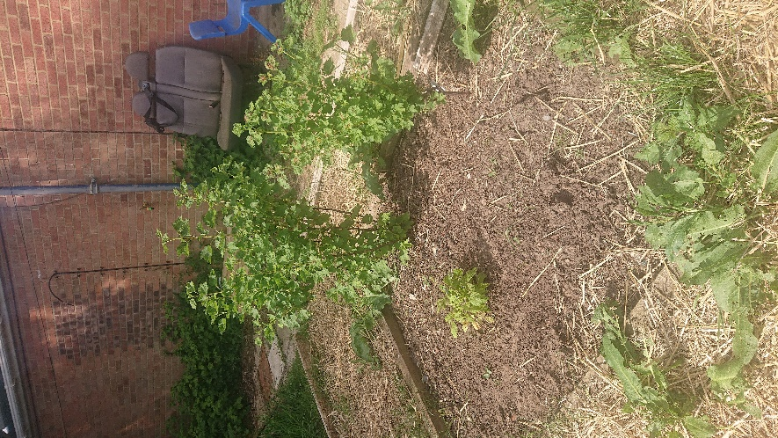

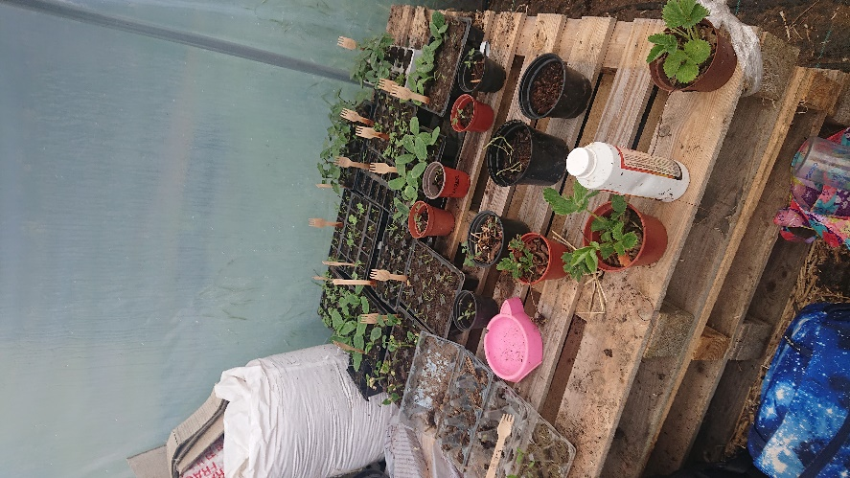
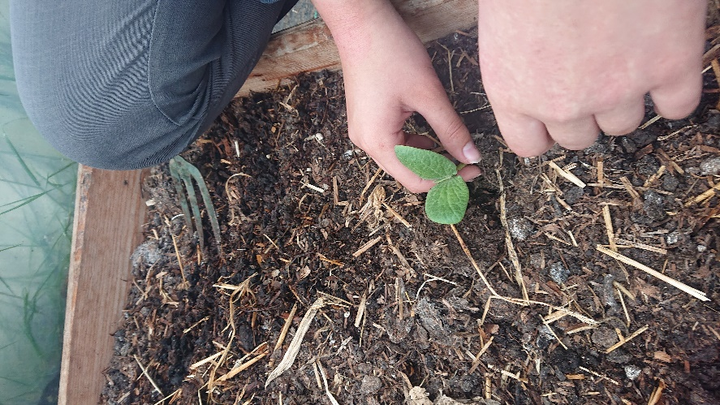

The under twelve seed tray competition (June 2024) taking place in Downham Preparatory School, Nelson Academy, Hillcrest Primary School and Denver Voluntary Controlled Primary School
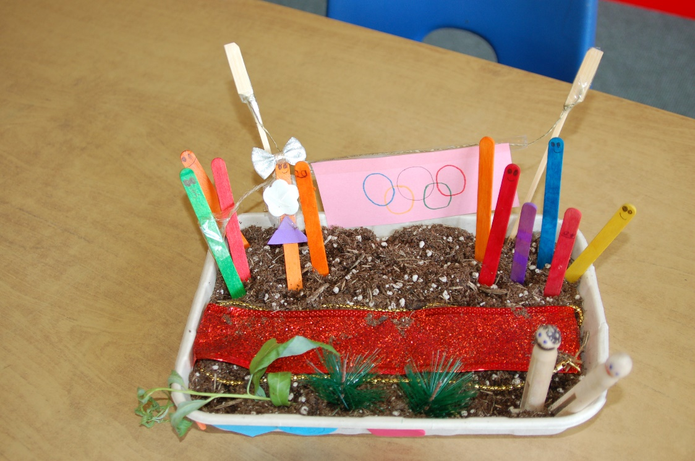

Downham Preparatory School

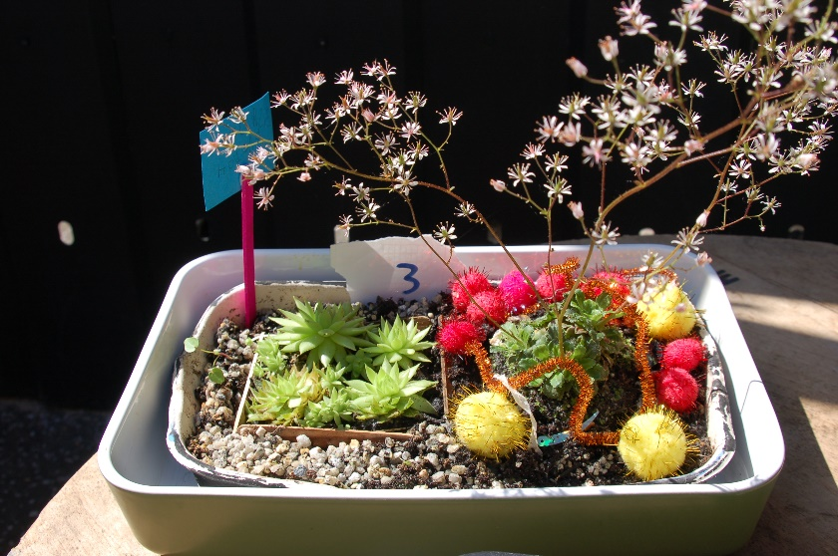
Denver Voluntary Controlled Primary School

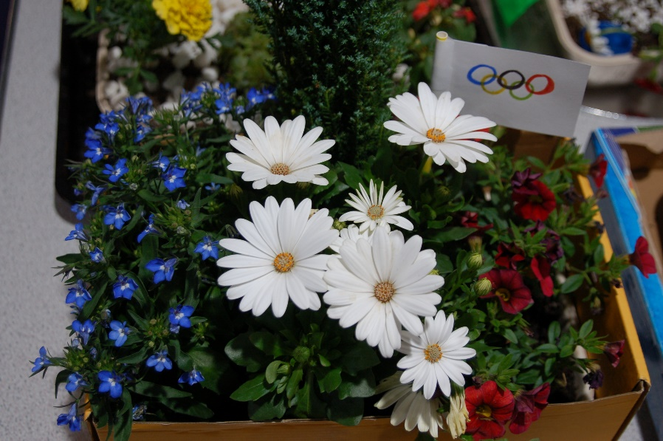
Hillcrest Primary School

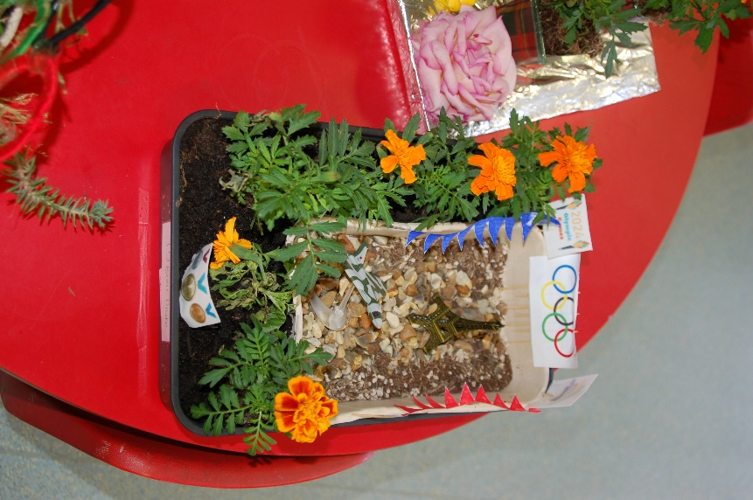

Nelson Academy

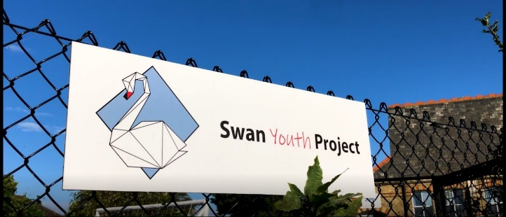
The Swan Youth Project Centre- a local youth facility who are creating tranquil spaces for young people to enjoy

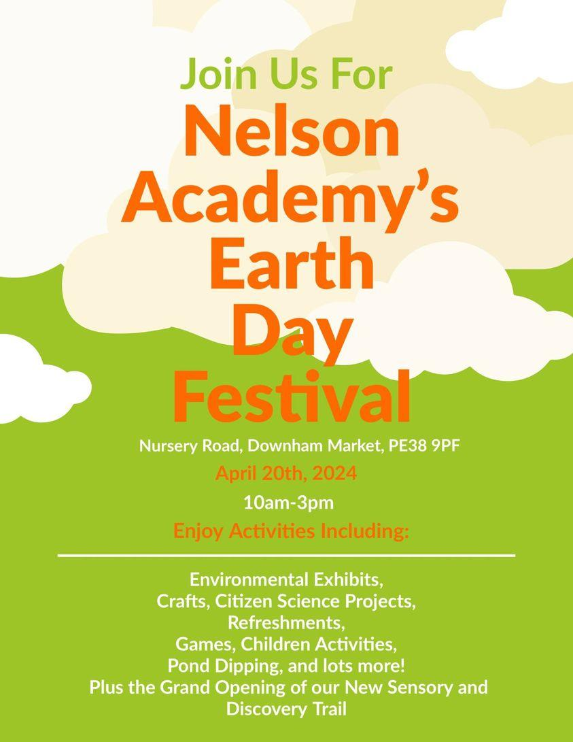
Nelson Academy- a local school that works positively to create an environment in which nature thrives, the school also participates in the annual seed tray competition

SECTION THREE - COMMUNITY
- Businesses and charities - the heartbeat of the town
- The town in bloom
- Annual Highlights
- Downham a town of diverse cultures
Community Development Chair Cllr Ali Buxton May 2023 - 2024
The community development committee had six councilors who meet monthly to discuss and plan upcoming events. These events are opportunities to benefit the community. Discussions were wide ranging and included the local authorities, community organizations and charities. The committee also oversaw the council’s grants policy and promoted tourism. Communication with residents is by way of the DMTC website, noticeboards, social media, and monthly full council meetings which are recorded as well as newspaper articles. The new council will continue these principles but led by the Business and Tourism Committee from May 20, 2024.
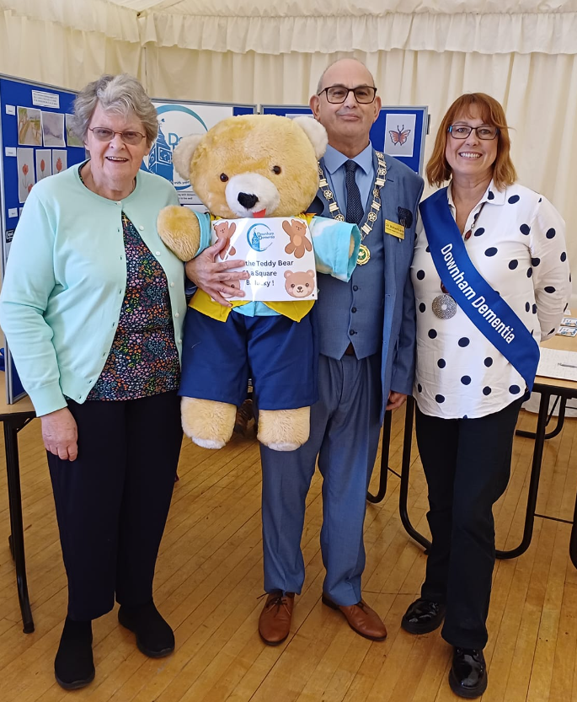

DMTC supporting local groups which work with the vulnerable in the community- in this case Downham Dementia

Business and charities - the heartbeat of the town

Winners of the 2024 Container Competition- Diamond House care Home
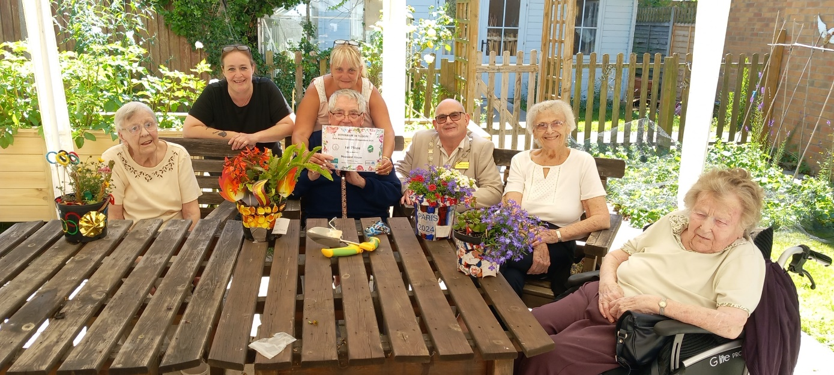

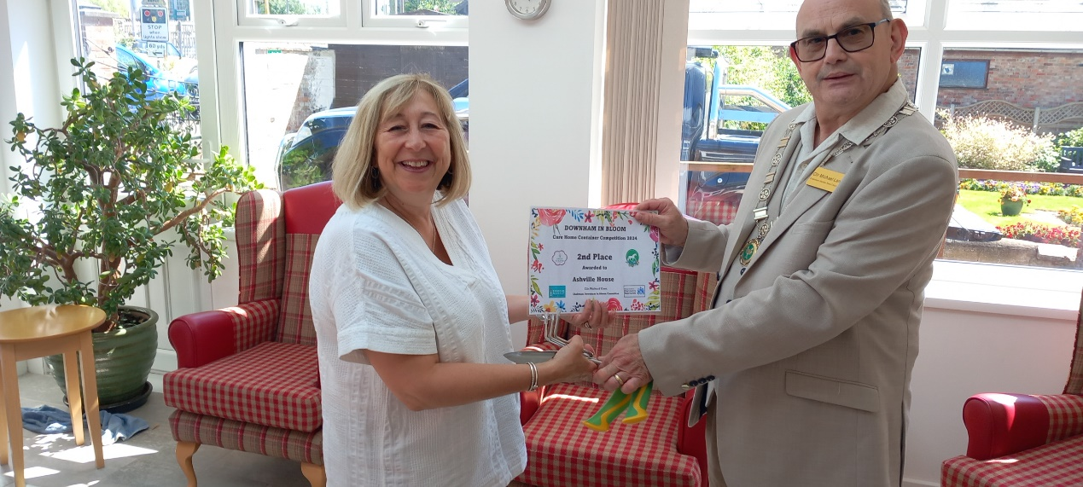
Congratulations to the runners up; Ashville House (pictured above), High Haven (below left) and Downham Grange (below right)
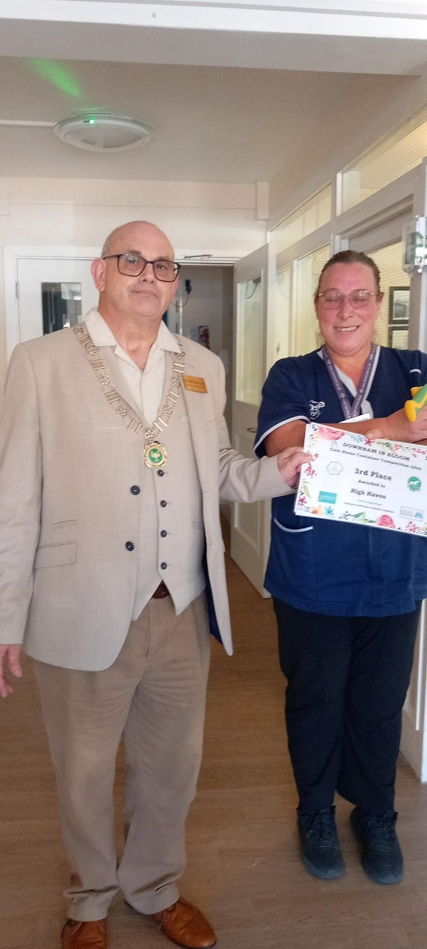
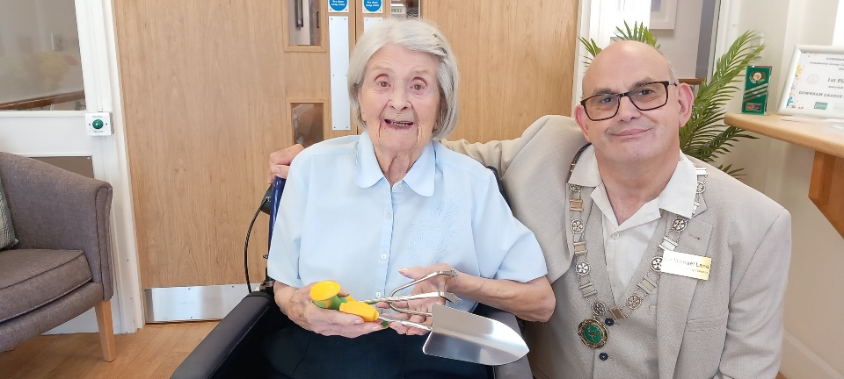

Each Care Home received a gift of an easy-grip cultivator and trowel
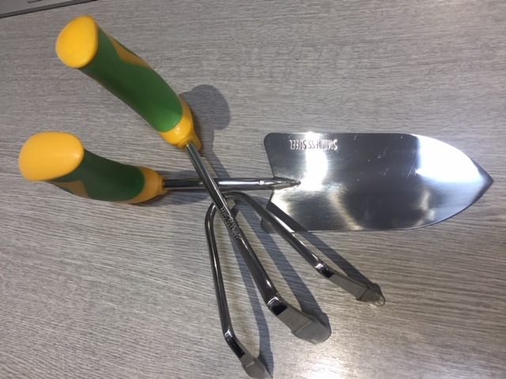

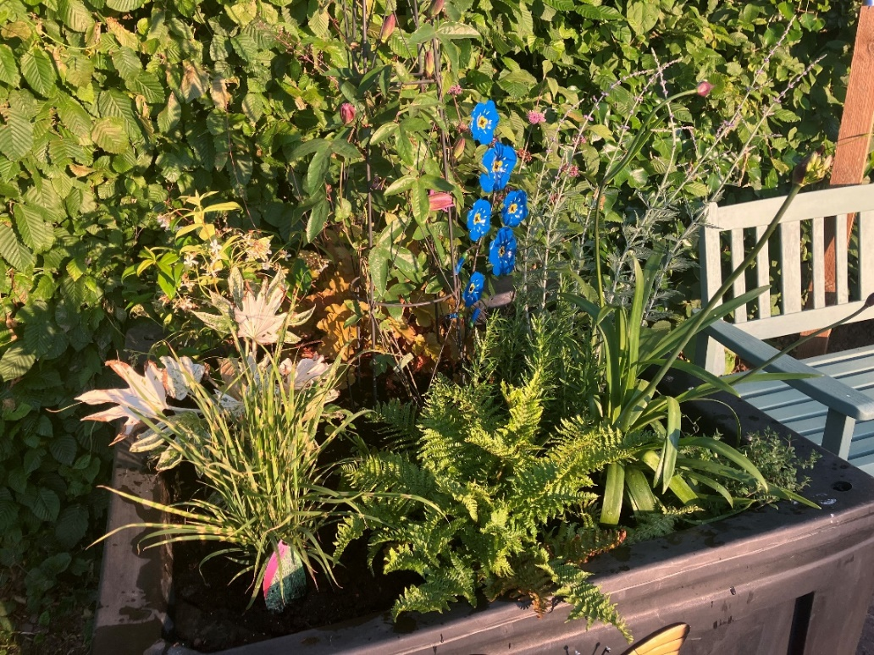

Forget-Me-Not Sculpture donated by Downham Dementia

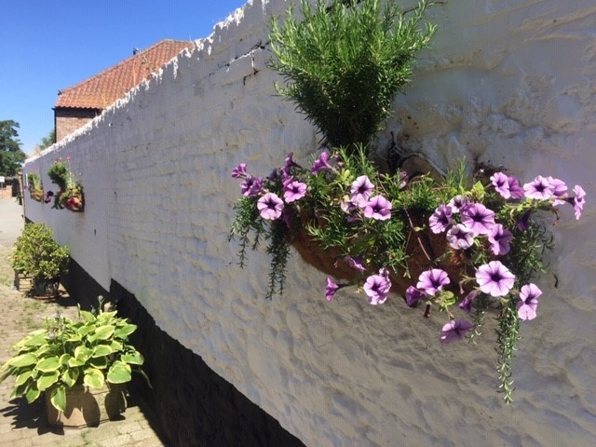

The Crown Hotel’s living wall

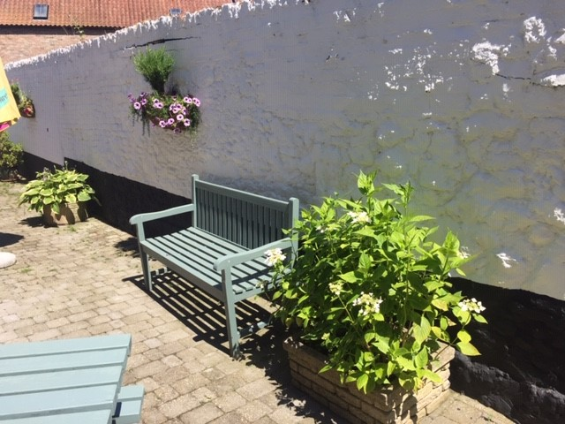
Bench and planters situated along the wall in the Crown Hotel’s courtyard

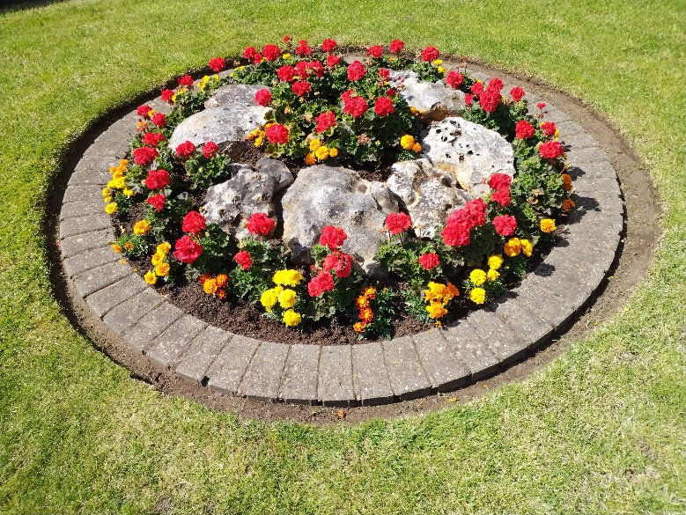

Barker Brothers DBS floral
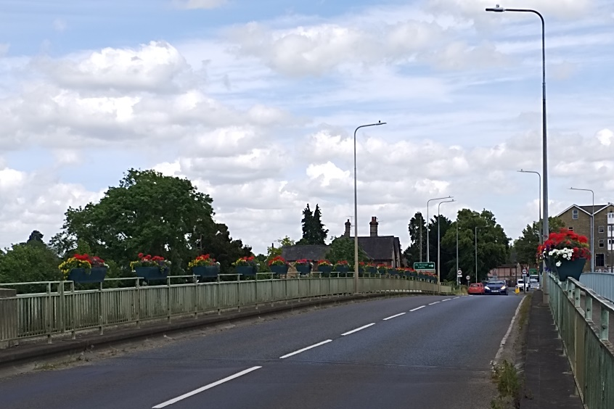
displays on show in the Summer (left and below)

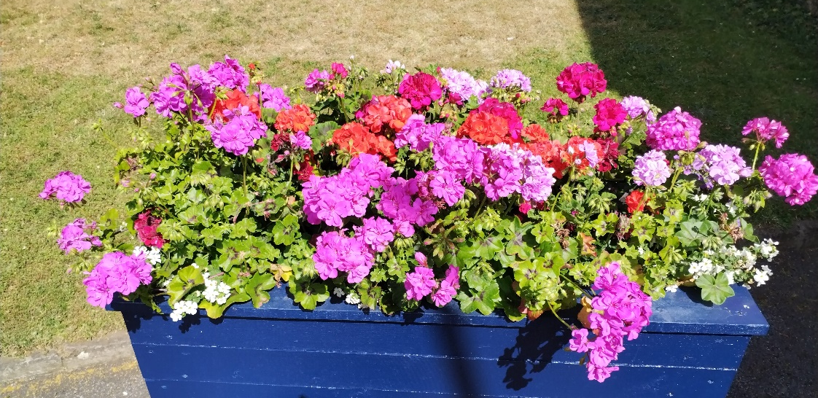

The bridge into Downham Market over the River Great Ouse lined by flower baskets provided by King’s Lynn and West Norfolk Borough Council
The town in bloom
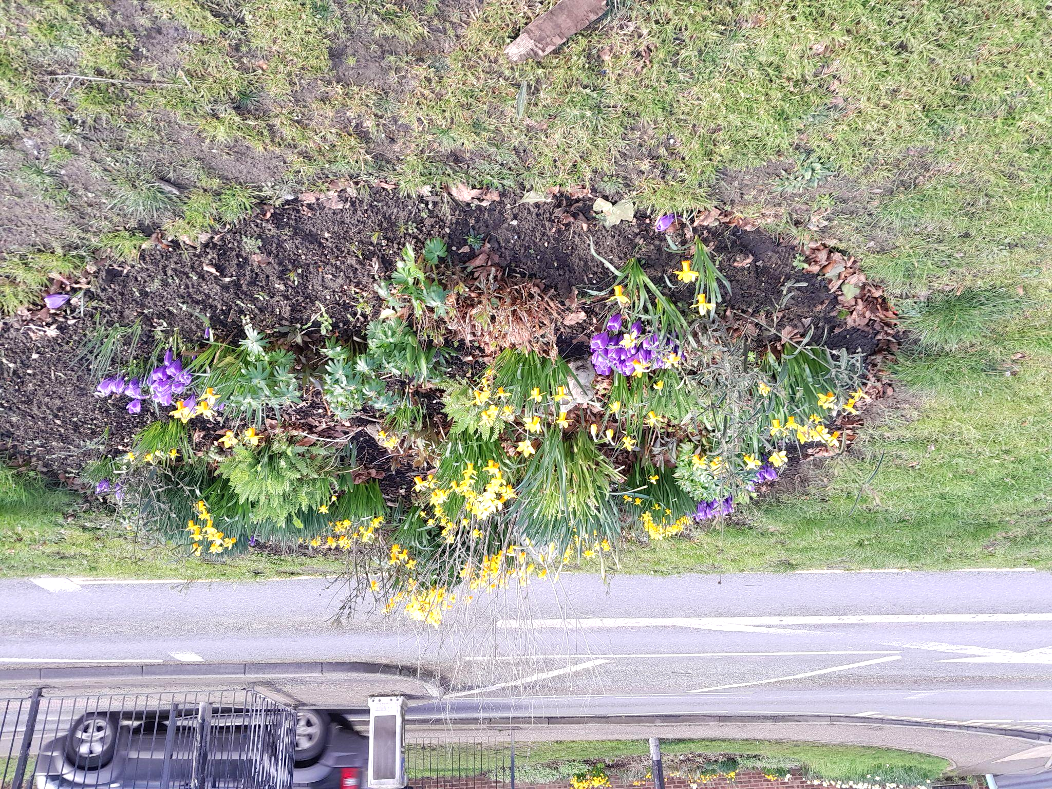
Spring 2024 planting - known as the Tesco roundabout managed by the Downham Market WI using sustainable planting

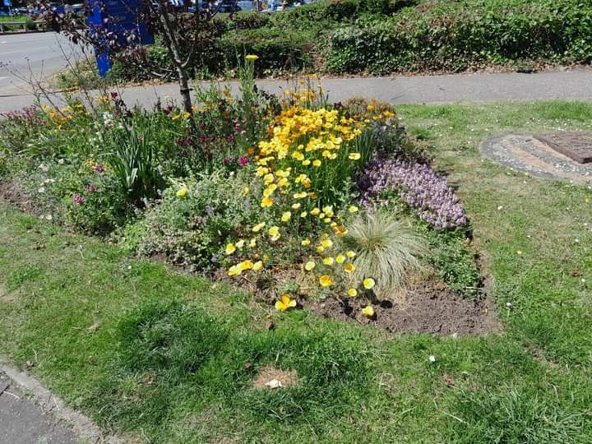

The Tesco roundabout in Summer 2024

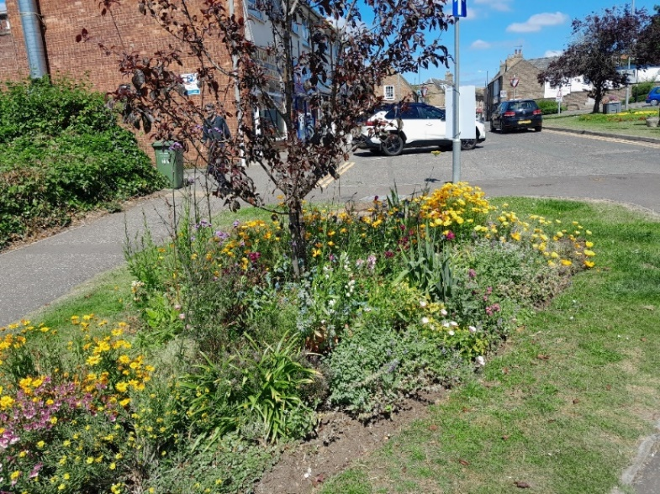

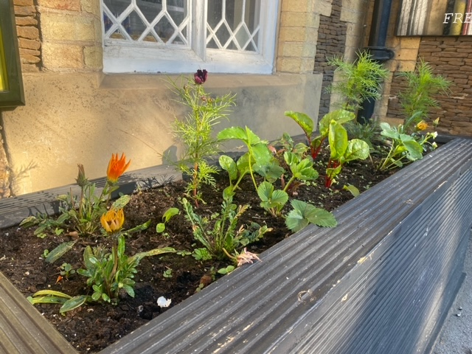

Planter situated at Downham Market Train Station (Spring 2024)

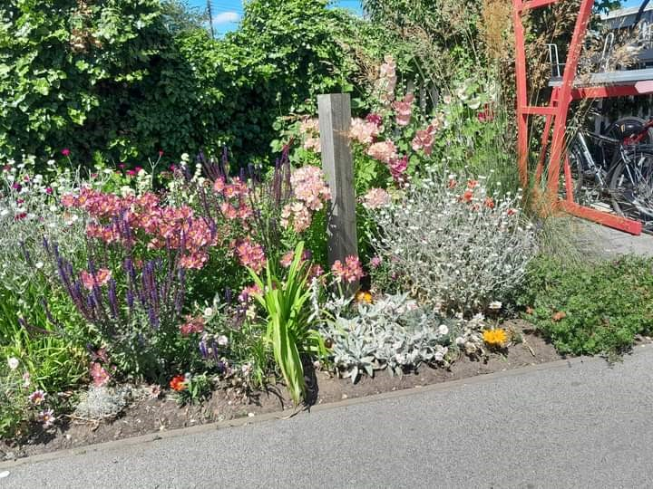
Flower bed outside the entrance to the Train Station

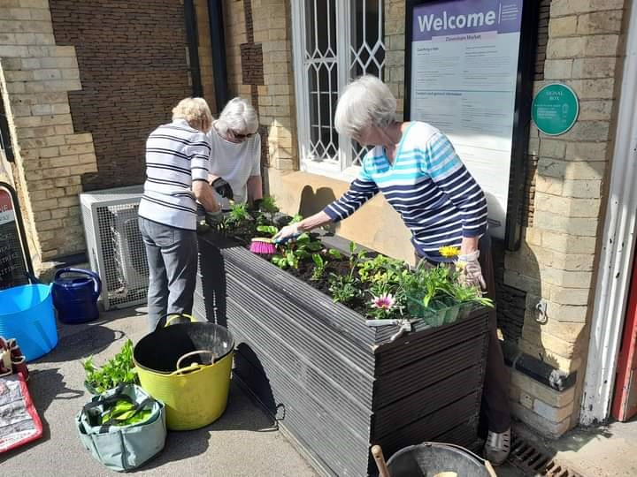
Flower beds and planters outside the Train Station- also managed by the Downham Market WI

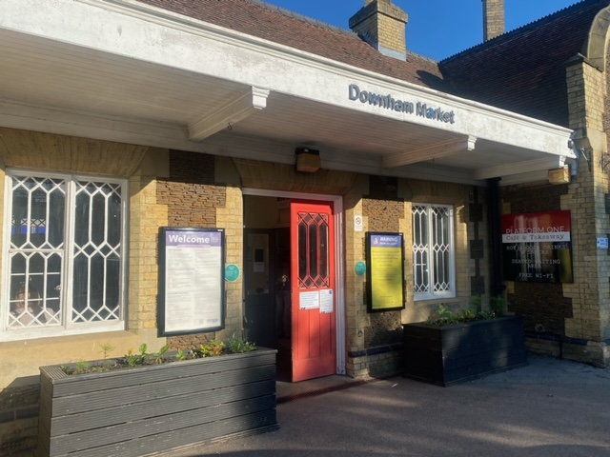
Front of Downham Market Train Station, a listed building and vital transport link in West Norfolk

Annual Highlights

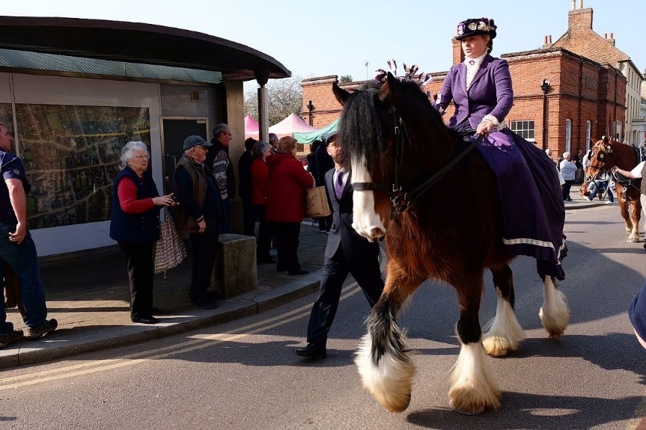
St. Winnold’s Day- celebrating Downham Market’s historical equine connections

Downham Remembers
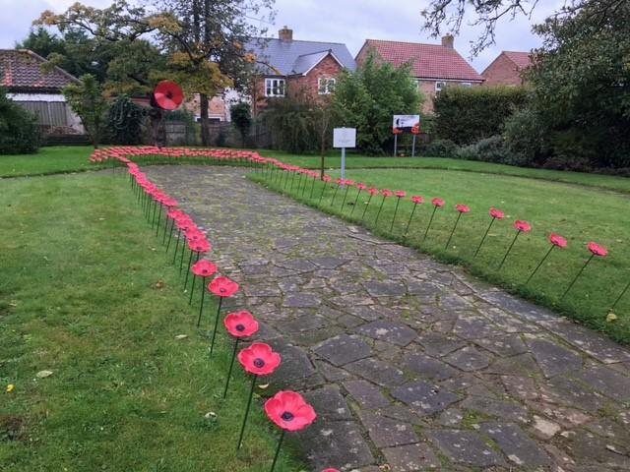
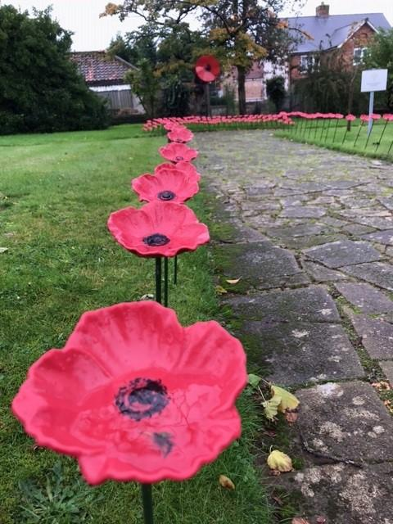

Happy to chat

A mental health & wellbeing initiative led by DMTC set in the
Alf Johnson Gardens - an all-year-round resource

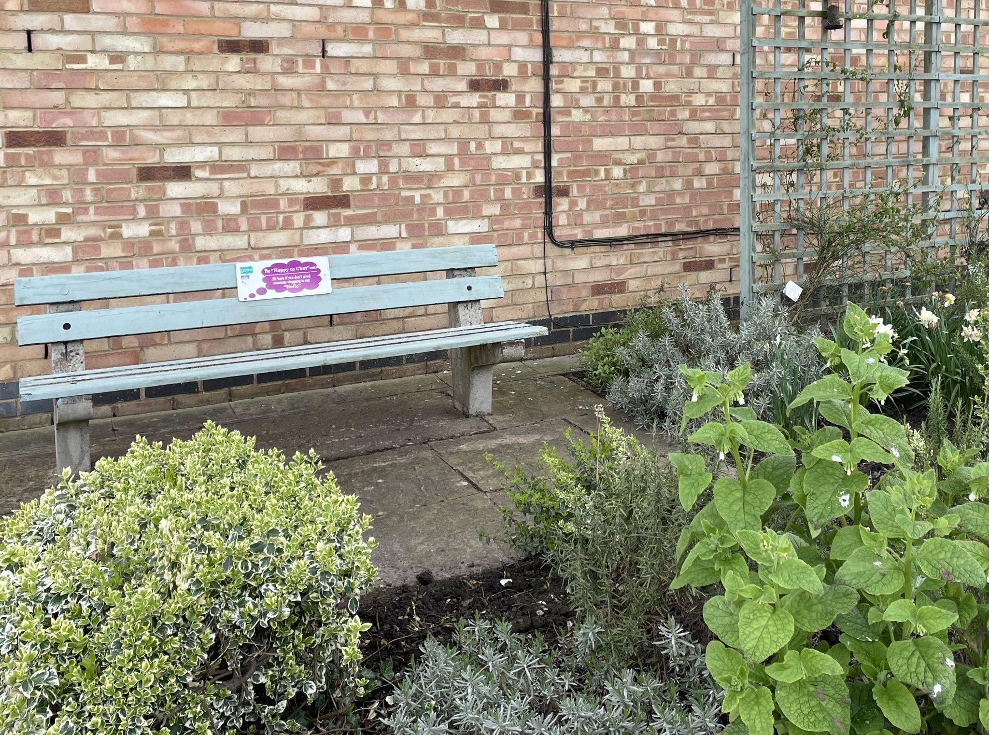

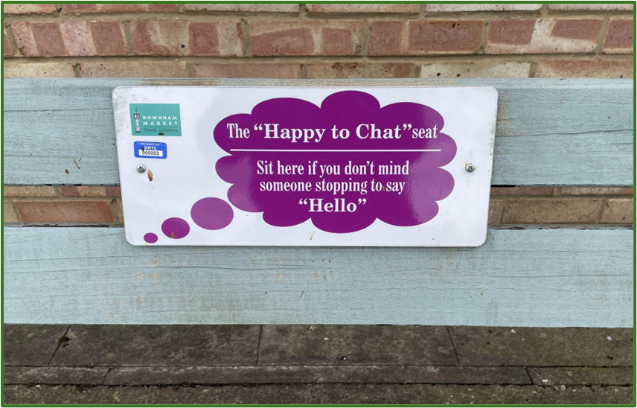

Future Plans

Jubilee Community Centre fields

The Jubilee playing fields are 2.5 hectares of open space in the heart of the town, it is a Fields in Trust area and therefore an open space for the community to enjoy. In 2024 Downham in Bloom began to work on the open space through creating planting areas. A regeneration working party was formed to develop the open space and the old community building that is on site. There are a range of plans to open it up for wider public use, including encouraging community groups to develop wildflower planting schemes bordering the site and plans to erect a planted-up picnic area and roadside hedging. Furthermore, amphibian and insect-friendly habitats are being set up at the Memorial Garden at the Memorial Playing Field. Finally, 2024/25 is a transition year for Downham in Bloom as it moves away from a committee structure- which used to deliver the objectives of In Bloom- to an events structure that will allow the Town Council to work all year round on projects to enhance and develop the biological sustainability within the town and meet the future objectives of In Bloom.

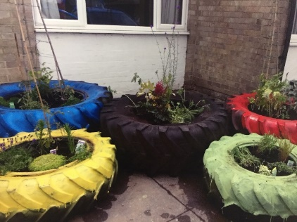

A water butt in the process of installation to capture rainwater for watering plants at the JCC (below)
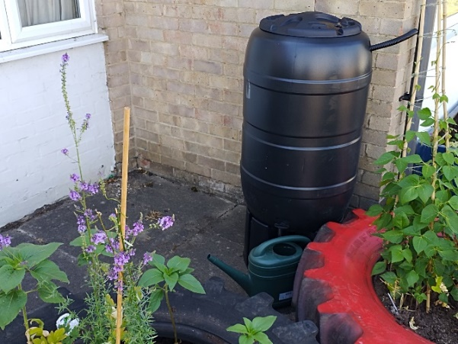

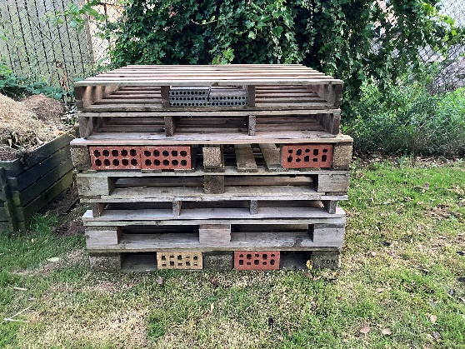
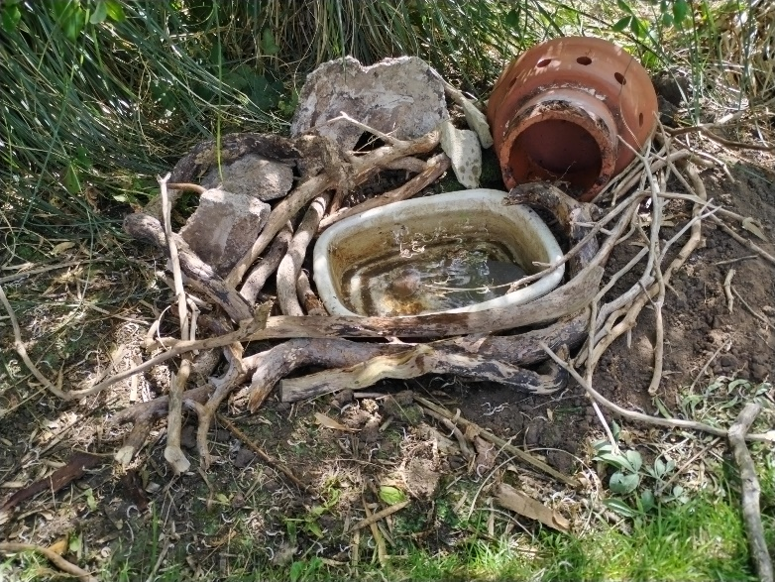
A newly created frog habitat at the Memorial Garden (below)

CONCLUSION & THANKS

We hope that you’ve had a pleasant trip around our historic market town and have enjoyed reading this portfolio detailing some of the activity in our community this year. We look forward to your visit next year where you will see the continuing sustainable developments in Downham Market.

Kind Regards, the Downham in Bloom Committee

With Thanks To

Barker Brothers DBS
Downham Dementia
Downham Market Academy
Downham Market Town Council
Friends of the Willows
Holly Landscapes
The Whalebone Public House
Women’s Institute- Downham Market
Nelson Academy
Downham Preparatory School
Hillcrest Primary School
Denver Voluntary Controlled Primary School

Downham in Bloom Committee

Cllr Michael Lane Chair of the Downham in Bloom Committee

Cllr Jacqueline D Westrop Vice Chair of the Downham in Bloom Committee and Rotary President

Cllr Frank Daymond Member of the Downham in Bloom Committee

Chris Durham Ground Operations Manager, Borough Council of King’s Lynn &West Norfolk

Nick Robinson Holly Landscapes

Pat Smith Women’s Institute

And with special thanks to

Luke Griffin Maintenance and Administrative Support Downham Market Town Council
